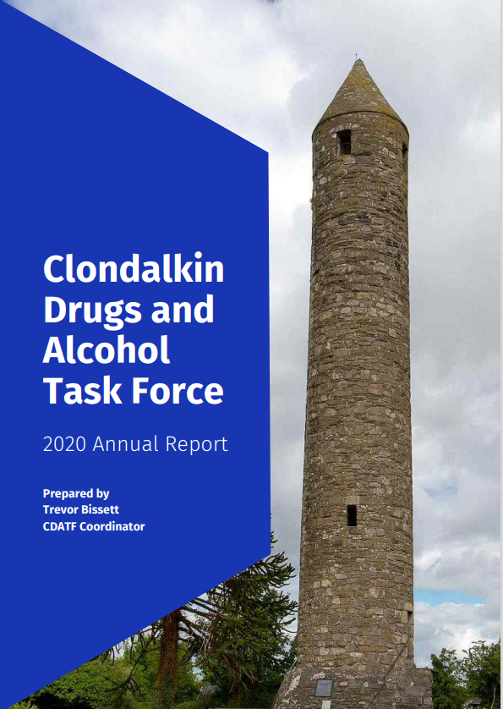ruth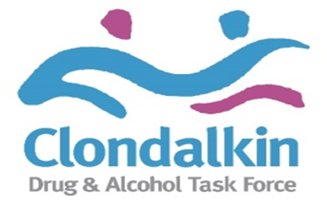

**Contents**

Introduction Page 4

1 CDATF Overview Page 6

2 Strategic Direction Page 9

3 Governance Page 10

4 Detailed Analysis of CDATF Area Page 11

5 Profile of Drugs Use in CDATF Area Page 15

6 Emerging Trends in Drugs Use Page 21

7 Activity Report 2022 Page 26

7.1 Staffing Page 26

7.2 Strategy Review 2022 Page 26

7.3 CDATF Achievements 2022 Page 26

7.4 Funded Projects Achievements 2022 Page 43

8 Board Membership Page 62

9 Appendices Page 63

A References Page 63

B Strategy Plan Implementation Table 2022 Page 64

C CDATF Strategic Plan Outcomes 2022 Page 73

D Accounts Page 92

**Introduction**

This Annual Report highlights the work carried out by and through the Clondalkin Drugs and Alcohol Task Force (CDATF) in 2022. Established in 1997, CDATF is one of 14 local Drugs Task Forces which are local area responses to the causes and consequences of drugs use in the areas most badly affected by these issues.

The Task Force model was founded as a partnership response to the complex issues presented by drugs. The establishment of CDATF reflected the belief that problematic substance use and its associated problems are generated and intensify largely due to socioeconomic issues. Through the work of the CDATF the aim is to tackle these issues using a joined-up approach. This joined up approach is coordinated by the CDATF in collaboration with other projects funded to provide services and is crystalised in our strategic plan and three strategic goals. These strategic goals are progressed through the efforts of the CDATF, funded projects and other key stakeholders in the area.

After the global shock experienced through the Covid pandemic CDATF and funded projects enjoyed a return to more conventional ways of working in 2022. Whilst many lessons were hopefully learned from the pandemic it is also clear that the experience has led to an uptick in people seeking help and people experiencing increased levels of anxiety and substance use. Many services are beginning to operate waiting lists for some services due to these increases. This increase in demand has not been helped by a very challenging labour market situation. Many services in Clondalkin and beyond are reporting major difficulties in recruiting staff. In terms of substance use trends, the view from projects, treatment figures and most relevant research is that cocaine and crack cocaine use has risen dramatically.

In 2022 the CDATF set out some new work priorities and areas of work. Firstly, it was decided to put a major focus on recovery. Many initiatives were developed including recovery cafes, a recovery choir and an interagency effort made around September for recovery month. This reflects the changing nature of substance use and need to provide improved aftercare supports for all of those in the recovery community. Service User Involvement was a major area of work also in 2022. To this end the CDATF has worked with a volunteer service user to develop a service user strategy. The community itself are the most important stakeholders in our work and the CDATF Community Reps Forum went from strength to strength in 2022. All of this was in addition to the annual addiction studies Level 7 programme that ran throughout the year, various training events such as SAOR, prevention workers training and case management training for workers.

The staff team of CDATF changed significantly in 2022. James Norman joined the team as the Coordinator of the YDAP project. This project seeks to provide a functional Tier 2 service in the area for under 18s experiencing issues with substances. Additionally, Nicholas Diez McKenna joined the team on a part time basis as a Service User Representative. We wish them both well in their roles. Tiernan Heaney and Grainne Finnegan departed from the board in 2022 and I would like to thank both for their service. As ever I would like to express my gratitude to all the staff, board, volunteers, and funded projects for all their hard work in 2022 and look forward to seeing what 2023 brings.

Pat Bennett

Chairperson

CDATF

**1 CDATF Overview**

**1.1 History of Clondalkin**

Clondalkin is a suburban town situated 10 kilometres west of Dublin city centre within the administrative jurisdiction of South Dublin. It is one of three new western Dublin towns proposed in the Myles Wright Report to cater for the growing population of the Dublin region at the time. The other proposed towns were Tallaght and Blanchardstown (1). The vision for these new towns was that they would be partially self-sufficient communities (2).

During the early 1970s and 1980s these towns experienced rapid growth in population, continuing to this day. This growth was fuelled by a demand for low-cost housing, the decentralisation of industry from Dublin city, and the development of industrial infrastructure. This growth was not without issues and areas of Clondalkin came to be severely affected by poverty and social disadvantage (3).

The centre point of Clondalkin is its historic village which features a round tower dating from the 8th century. The village is bordered by the neighbourhoods of Surleen and Knockmitten. To the north of the village is the Grand Canal. Beyond the canal are the neighbourhoods of Quarryvale, Rowlagh, Neilstown and Balgaddy. To the south and west of the canal the neighbourhoods of Bawnogue, Deansrath and Clonburris can be found.

**1.2 Early Demographic Profile**

It is over 30 years since the 1991 Census which recorded a very high percentage of young people relative to other age groups residing in Clondalkin. At the time, 37% of the population were aged 1-14 years and only 3% of the population were over 65 (4). Also, at this time it was reported that households headed by lone parents made up 17.9% of households in Clondalkin (5). There were few employment opportunities at the time which was reflected by a high unemployment rate. As a whole, the Clondalkin unemployment rate was 26% but this was as high as 44% in some areas (4). A damaging pattern of early school leaving was also evident in the 1991 census that reported that 40% of the population in Clondalkin left school at the age of 15 or under (4).

**1.3 Emergence of Opiate Use and Community Response**

Much of Dublin experienced a large increase in opiate use during the 1980’s peaking around 1985 (6). At the time the problem was overwhelmingly concentrated among young males between 15 – 24 years old (7). Though initially associated with inner city neighbourhoods the ‘opiate epidemic’ also reached out to the newly established suburb of Clondalkin.

In the early days the heroin problem in Clondalkin was mainly situated in North Clondalkin. Community groups in the Quarryvale area of North Clondalkin emerged and were instrumental in establishing Clondalkin Addiction Support Programme (CASP) as a grass roots response to the growing problem of heroin use in the area. Needs related to opiate use also emerged in Southwest Clondalkin at a later stage.

The Clondalkin Drug and Alcohol Task Force was established in 1997 as a statutory response to the issues associated with opiate use (8). It was one of 14 Local Drugs Task Forces established by the Government in response to the heroin epidemic occurring mainly in the Dublin region. The aim of these Task Forces was to take a partnership approach to complex issues and provide locally appropriate responses.

Since then, problematic drug use in Ireland has changed significantly and while heroin use remains a significant problem there is growing public concern regarding problems associated with polydrug use including cannabis, cocaine, alcohol and prescribed drugs such as benzodiazepines and other Z drugs (9).

**1.4 Catchment Area and Strategy Response**

Clondalkin Drugs Task Force serves Clondalkin and the surrounding areas of Lucan, Palmerstown and Newcastle. These areas form the Dublin Mid-West Dail constituency with a population of 117,976 in 2016 (10).

To date, the CDATF has developed three local area strategies. Under our current strategy, the CDATF aims to respond to drugs and alcohol issues, work with all stakeholders and improve the coordination and delivery of services in the area (11). This strategy was developed with local stakeholders to synthesise the views and needs of the local community with the goals of the government’s national drugs strategy Reducing Harm, Supporting Recovery (12). It is delivered on through the work of local service providers in partnership with the community, voluntary and statutory sectors.

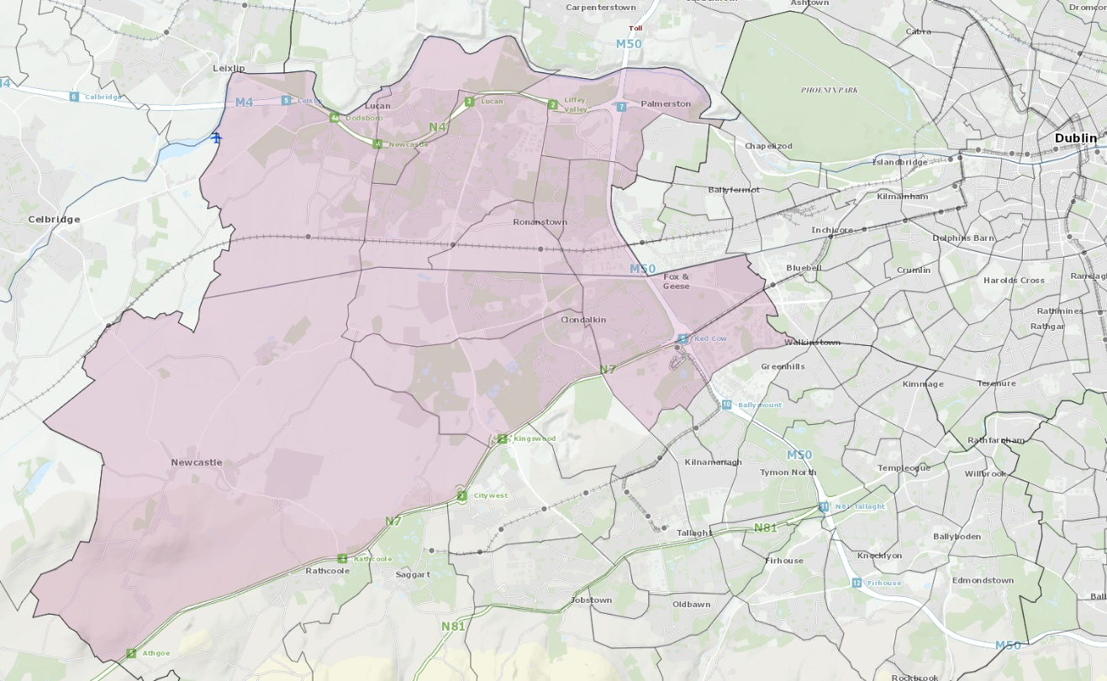

Figure 1 Geographical Area Covered by CDATF and Funded Services

**1.5 Organisation Structure**

The CDATF is a Company Limited by Guarantee (CLG) that has also attained charity status. It can be understood as having a dual role. This role is to provide services to the community directly and contribute to an integrated approach amongst National Drugs Strategy funded projects in the area. Both roles are overseen by the board of the CDATF. The board is made up of local community members, voluntary reps, and statutory representatives. This partnership approach is at the heart of the work of the CDATF.

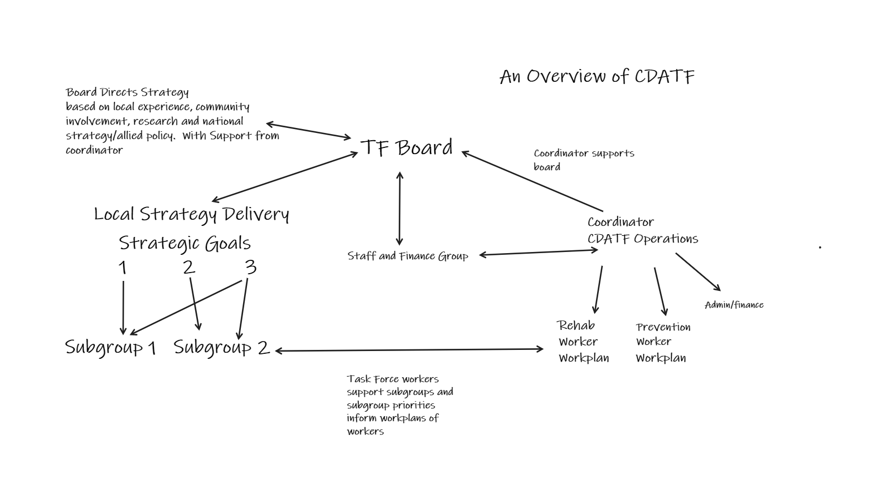

Figure 2 CDATF Organisational Overview

**2** **Strategic Direction**

CDATF’s strategic direction is set out in its Strategic Plan. The plan is guided by our mission statement. How we perform this mission is underlined by a set of four values which inform our approach. We endeavour to fulfil our mission through advancing our three strategic goals.

**2.1 Mission Statement**

“To re-establish and strengthen the role of the community in tackling the causes and consequences of drug and alcohol misuse; facilitate the re-establishment of meaningful and effective partnerships; and support the development of a holistic approach to dealing with both the causes and consequences of drug and alcohol misuse in the CDATF area.” (11).

**2.2 Our Values and Approach**

1 A Community Development Approach

2 A Person-Centred Approach

3 A Human Rights Based Approach

4 An Evidence Based Approach

**2.3 Strategic Goals**

Goal 1 Deal with the effects of drug and alcohol misuse.

Goal 2 Strengthen the role of the community in addressing the causes of drug and alcohol misuse.

Goal 3 Positively influence mainstream services and contribute to more integrated responses.

**2.4 Strategy Plan**

CDATF’s strategic plan was written in 2018. A process to review this strategy was commenced in 2021 and new priorities and actions were identified for 2022-2025 (see appendix 1). These new strategy actions are in line with the midterm review for the National Drugs Strategy and include six Strategic Implementation Priorities. The progress on these actions was reviewed by the CDATF board in January 2023. They are included in appendix 2.

**3 Governance**

CDATF is a Company Limited by Guarantee and a registered charity. The organisation receives funding from the HSE and Department of Health. As such there are several governance frameworks that the organisation must comply with on an annual basis.

The Board of the CDATF is responsible for overseeing the performance and governance of the organisation. CDATF applies a governance framework to how it makes decisions and achieves its goals. This framework consists of many legal, financial, and regulatory standards that must be adhered to, in order to govern the performance of CDATF well.

As the CDATF is a registered charity we are obliged to provide a return to the Charities Regulatory Authority (CRA). This return outlines how the governance of the CDATF adheres to the CRA governance code. There are six principles in the code. CDATF has demonstrated its compliance with the code by developing a plan to adhere to the principles and have evidence of work towards this plan.

This compliance checklist has been completed by the organisation and was signed off on 12th October 2023 at the board’s monthly meeting. We have declared our compliance with the CRA Governance Code as fully compliant with the code, (Declaration A).

**4 Detailed Analysis of CDATF Area**

**4.1 CDATF Area Profile**

The CDATF cover the Dublin Mid-West constituency area of Clondalkin, Lucan, Palmerstown and Newcastle and has a population of 117,976 (10). The South Dublin County Council has described the demographic change across the county as extremely varied with Lucan LEA increasing by 22.1% (+10,073) and Clondalkin LEA increasing by 10.9% (+5,090) (13). Key demographic data is due to be published from Census 2022 over the coming months that is likely to show significant increases in the population of the area.

**4.2 Deprivation**

The Pobal HP Deprivation Index is a series of maps measuring the relative affluence or disadvantage of a particular geographical area in the Republic of Ireland. Clondalkin resides in the South Dublin County area and scored -4.0 in 2016 (14). These figures represent a wide geographical area including many affluent areas outside of the CDATF catchment area. A more accurate representation of deprivation can be observed in a recent SDCCPPN ‘poverty map’ which highlighted areas of deprivation ranging between -12.06 to -17.55 (15). These figures put many areas in the CDATF area among the most deprived in the state.

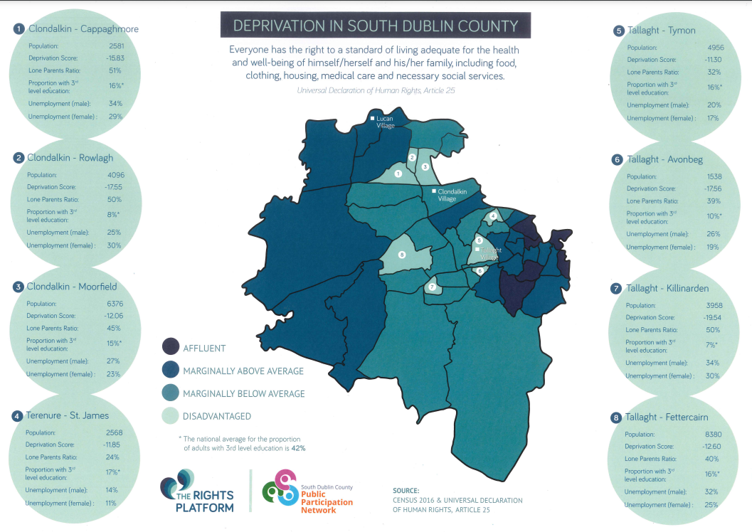

Figure 3 Deprivation Map South County Dublin

**4.3 Housing**

According to Census 2016, the total households with tenure of social rented residing in South Dublin were 10,921. This represented 11.8% of the total households. This proportion was higher than the State average of 9.4% and the Dublin regional average of 10.6% (10).

Relative to other areas, South Dublin had the fifth highest rate of social housing households in the State. Of the four Dublin local electoral areas (LEAs), South Dublin had the second highest rate. The highest rate being in Dublin City (13%), followed by South Dublin, DLR (6.8%) and the lowest in Fingal (6.7%)(10).

**4.4 Lone Parent Households**

According to Census 2016, the total ‘Lone Parent’ families with children under the age of 15 residing in South Dublin was 15,559. This represented 24.0% of the families with children under the age of 15. Lone mothers accounted for 22.6% (7,723) and lone fathers 1.5% (509). This proportion was higher than the State average of 20%, the Eastern and Midlands average of 21.1% and the Dublin regional average of 23.5% (16) .

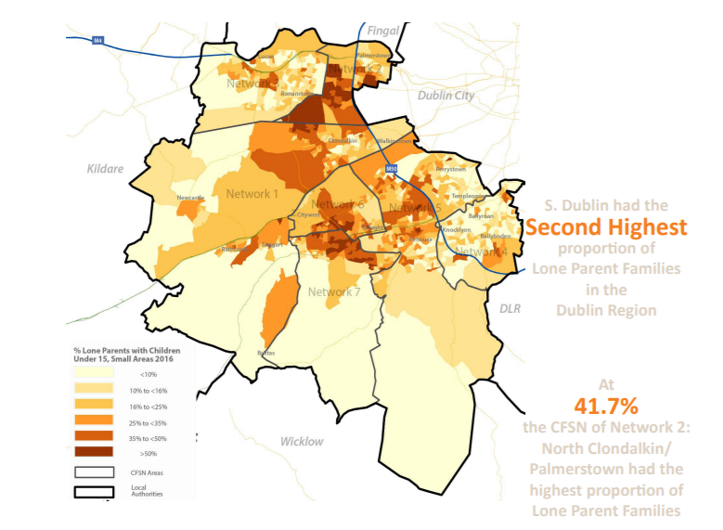

Figure 4 Lone Parents Households South Dublin 2016

**4.5 Youth Population**

The CDATF area possesses a higher ‘Young Dependency Rate’ than many other areas in Dublin. This rate is calculated as a percentage of the population between 0 and 15, compared to the 15-64 age group. The average across Dublin is 28% whereas in Clondalkin this rate is as high as 34.6% in South Clondalkin, and 29.7% in North Clondalkin. Ronanstown and Balgaddy Road in North Clondalkin have particularly high youth dependency rates (16).

**4.6 Emerging Adults**

There were 23,129 young people aged 18 to 24 years residing in South Dublin according to Census 2016. This figure represented 8.3% of the total population in South Dublin. This proportion was higher than the State average of 8.2%, lower than the Eastern and Midlands average of 8.6% and the Dublin regional average of 9.3% (10). Relative to all other LEAs, South Dublin had the eight highest proportion of young people aged 18 to 24 years with Galway City having the highest at 14.2% and Leitrim the lowest at 5.9%. Of the four Dublin LAs, Dublin City had the highest at 10.4% and DLR (10.1%) the second highest proportion of 18 to 24 year olds. The lowest rates being in South Dublin (8.3%) and Fingal (7.6%) (16).

**4.7 Ethnicity**

South Dublin is very ethnically diverse by Irish standards. When compared to the greater Dublin region it contains the second lowest proportion of ‘White Irish’, the second highest proportion of ‘White Irish Travellers’ and the second highest proportion of ‘Black or Black Irish’(16).

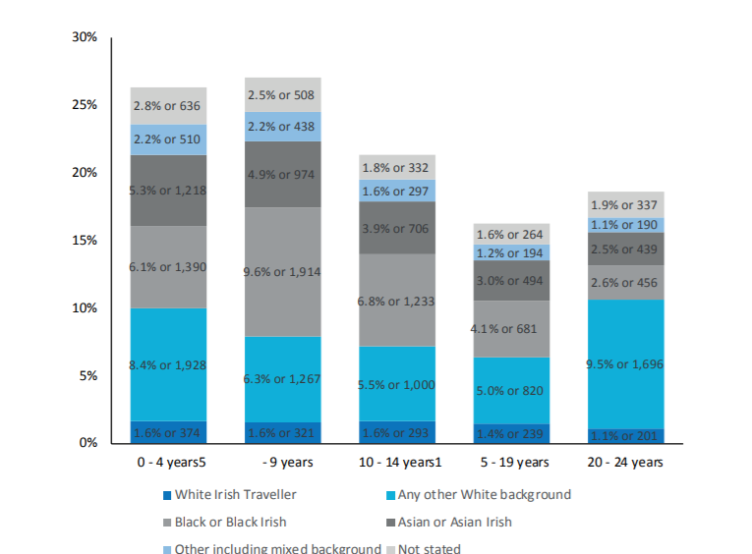

Figure 5 Ethnicity by Youth-Age Group Census 2016

**4.8 Employment**

According to Census 2016, the total population unemployed and residing in South Dublin was 18,265. This represented 13.3% of the total labour force (At Work and Unemployed). This proportion was higher than the State average of 12.9%, the Eastern and Midlands average of 12.4% and the Dublin regional average of 11.6% (16).

**4.9 Education**

In 2016, the total students that sat the Leaving Certificate examination in South Dublin was 2,794. Of this figure, 69.7% or 1,948 of the students progressed to third level. This proportion was below the State average of 77.8% and relative to all other local authorities was the second lowest rate of progression in the country. On a comparative basis, DLR had the highest at 91.6% and Dublin City the lowest at 66.4% (16).

According to Census 2016, the total population residing in South Dublin with ‘Third Level’ education was 56,821. This represented 32.6% of the total population in South Dublin that had completed their education. This proportion was lower than the State average of 33.4% and the Dublin regional average of 40.7% (10).

Figure 6 Naloxone Training in 2022 Co-facilitated by CDATF Service User Representative

**5 Profile of Drugs Use in CDATF Area**

**5.1 Drugs Use**

A complete picture of the number of people receiving treatment for drug and alcohol use in the CDATF area is difficult to access. Data is available from the Health Research Boards through the National Drug Treatment Reporting System (NDTRS) but not all services are included in this system, as a result, NDTRS figures greatly underestimate the level of treatment and drug related need in the area. In 2022 the NDTRS data supplied to CDATF by the Health Research Board show that a total of 596 cases were reported to the system resided in the CDATF area (17). This compares with data from the previous year that showed that 563 individuals engaged in treatment and rehabilitation services locally (18). This marks a rise of 6% on the previous year.

These 596 cases of treatment are dominated by three substances. These are cocaine, heroin and alcohol which accounted for 414 of the 596 cases reported. Cocaine was the substance most people resident in Clondalkin sought treatment for in 2021 representing more than a quarter of all cases. This was followed by alcohol with 136 cases and heroin with 118 cases. Cannabis and benzodiazepines represented 72 treatment cases and 40 cases respectively.

Figure 7 Reason for Referral 2022

(18). These overall figures show that cases in the area increased across all substances with the exception of opiates which decreased slightly on previous year.

**5.1.1 Cocaine**

Cocaine use has become increasingly prevalent in Irish society in recent years. This can be seen in a gradual upward trend recorded in the Irish National Drugs and Alcohol Survey (19).

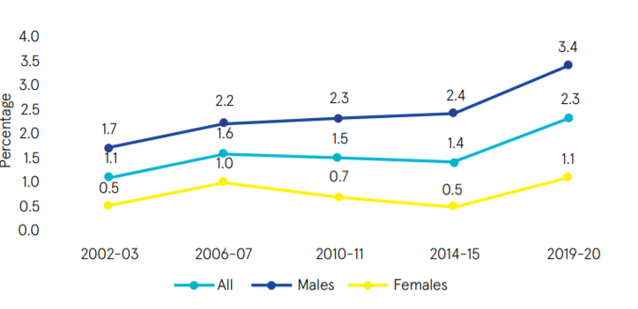

Figure 8 Increase in National Cocaine Use 2002-2020

At a local level 160 people resident in Clondalkin were recorded in the NDTRS figures as being treated for cocaine use in 2022. These figures are an increase of 10 from the 2022 figure of 150. These figures also demonstrate the continued upwards trend of people presenting with issues related to cocaine. The 2022 figure of 160 cases compares with 150 cases in 2021, 98 cases in 2020 and 75 cases in 2019. These figures are likely being swelled due to a growing number of people being treated for crack cocaine use over the past five years in the area. Between the years 2015 and 2019 the numbers of people accessing treatment for crack cocaine as a main substance issue increased from 8 to 15 and as a secondary issue from 23 to 32 (18).

Figure 9 Increase in Cocaine Treated Cases 2019-2023

**5.1.2 Alcohol**

In 2022 there were 136 people who presented for problematic alcohol use issues. Again, a significant increase was observed from the 2021 figures showing 111 people sought help for problematic alcohol use issues. When combined with those receiving treatment for alcohol as an additional problem this number rises to 177. Of these 64 were classified as dependent drinkers which was a slight rise on 2021’s figure of 59.

Figure 10 Extent of Problem Drinking NDTRS 2022

**5.1.3 Opiate/Heroin**

The total number of people treated for problematic opiate use according to NDTRS figures in 2021 was 134. In 2022 the figure decreased to 118.

A supplementary source of information for opiate use in Clondalkin is the Methadone Central Treatment List (CTL). This list logs all people receiving opiate substitute treatment. The most recently available CTL listing for 2020 showed that there were 550 individuals residing in the CDATF area receiving opiate substitute treatment. Of these none were under the age of 24 with the majority of 496 being over 35 years of age.

|  |  |  |  |  |  |
| --- | --- | --- | --- | --- | --- |
| Gender | Clinic | NDTC | GP | Prison | Total |
| Male | 169 | <10 | 173 | 30 | 377 |
| Female | 97 | 0 | 66 | <10 | 173 |

Figure 11 Central Treatment List Clondalkin 2020

**5.2 Demographics of Treated Use**

As stated above the figures produced by NDTRS are not an ideal dataset to describe the scale of the drugs issue in Clondalkin. There are several issues with these data. For instance, not all services currently report through the NDTRS for example. However, they are presented below as an indicator of trends in treated drugs use that can be extrapolated to the wider area.

**5.2.1 Age Group**

In 2022 most treated cases in the area were spread across the age groups between 25 years and 45 years representing almost 66% of treated cases. This was the same as the previous year’s figure. The number of people in the 45-49 age group decreased from 64 in 2021 to 51 in 2022. The number of treated cases in young people or emerging youth 0-24 remained steady.

Figure 12 Age Grouping of Treated Cases 2021

**5.2.2 Accommodation**

Of the total number treated in 2022 most reported as having stable accommodation. A small percentage were homeless and another small percentage in unstable accommodation.

Figure 13 Accommodation Status

**5.2.3 Education & Employment**

Of those treated for substance use issues in 2022 over 60% were unemployed or unable to work. About 26% of those in treatment in 2022 were in employment and the remaining 15% were made up of people in education/training, retired or had an unknown status.

It is worth noting that the minimum school leaving age by law in Ireland is 16 years old. Of those in treatment in 2022 over 30% left school before 16 years of age.

**5.2.4 Gender**

There is a split of 66% male to 32% female in terms of the gender breakdown for treated cases in the CDATF area in 2021. This compares against 62% male to 38% female in 2021 and 68% male and 32% female in 2020.

Figure 14 Gender of Treated Cases 2021

**5.3 Source of Referral**

Most people referred themselves for treatment in 2022 and this was the case again in 2021 with self-referral accounting for 61% of total. Significant sources of referral other than self-referral were drug treatment centres, family, friends, and professionals such as GP’s or mental health professionals. There was a notable rise in numbers of referrals received from schools/colleges in 2022.

Figure 15 Source of Referral 2021

**6 Emerging Trends in Drugs Use**

**6.1 Strategy Review**

As part of a review of the CDATF strategy commenced in 2021 a survey was conducted to garner views on prevalence and nature of substance misuse, it’s impact on CDATF communities and appropriate responses, which was completed on-line/in hard copy by 125 respondents. The findings are provided below (20). Verbatim quotations are included to provide further clarity and context to the responses.

**6.1.1 Profile of Respondents**

Analysis of the respondent profile reveals that

* 69% were female (n=86) with 31% male (n=39)
* 73% (n=91) live in the CDATF area while 54% (n=67) also work in the area, 15% (n=18) have family or attend education in the area.
* The majority of respondents were from Clondalkin Village, Rowlagh, Moorfield, Cappaghmore, Lucan, Bawnogue, Deansrath, Ronanstown & Neilstown
* Adults aged 36-45 had the highest number of responses (n = 52), followed by adults aged 46-55 (n = 29) and adults aged 26-35 (n=27).
* Young people aged 25 and under made up 5% of responses (n = 6) with people aged 55+ accounting for 8% of the responses (n = 11).

**6.1.2 The Current Situation**

Respondents were asked about their perception of the extent to which the substance misuse and its impacts have improved or worsened over the past four years. 76% (n=95) felt that the situation was worse or much worse while 24% (n=30) felt it had remained unchanged or had improved. The view that the substance misuse landscape is more challenging now than it was four years ago was shared by the stakeholders and key informants in the consultation.

Figure 16 Perception of Change

The areas of Bawnogue, Neilstown, Balgaddy, Canal, Rowlagh, Quarryvale and Ronanstown were identified as the most impacted by substance misuse in the CDATF area. Contributors conveyed a range of visible and non-visible impacts of substance misuse spanning, community infrastructure, family, young people, educational and life opportunities, health and well-being, community resilience and the presentation of increased ruthlessness and violence.

*“Fear that no one talks about their kids getting involved sucked in shame keeps people so quiet as does the fear of retributions, it's anti-social behaviour, intimidation of local shop owners and their customers, increase in the numbers murdered also”*

*“Impact on families breaking up, financial burden, school dropouts, generational addiction and poverty, Drugs move to quieter areas, but issues follow then, Communities feel fearful and powerless. People start to avoid certain areas, under report issue as nothing is being done and it lowers the confidence in policing”*

*“Visible distress in people and their families. Mental and physical health deterioration in drug users’ personal well-being. Nonvisible distress on family members trying to support this misuse in their home. A sense of hopelessness and huge stress on the whole family”*

**6.1.3 The Main Causation Factors**

When asked as to what they felt the reasons for their much worse/worse prognosis with the option of choosing three responses, 53% (n=66) felt that the normalisation of drug use was the primary underlying factor with 48% (n=60) indicating that the trend of starting to use drugs at a younger age was the primary driver.

46% (n=57) felt that poor mental health across the CDTAF community was the main contributing factor with the visibility of drug use and the increased range of drugs available also cited by a significant proportion of respondents. The emergence of new and more addictive substances and the poverty and deprivation in the area and its impact on the life chances of young people were highlighted as causation factors for the escalation of substance misuse in the CDATF area.

Figure 17 Causation Factors

*“Drugs have become more accessible and very public in terms of supply and therefore normalised in Clondalkin communities.” It is happening at a much younger age than even 3-4 years ago; higher strength weed is more addictive and the younger they start the harder it is to identify other issues that may be going on such as mental health”.*

*“The bling of the drug dealing lifestyle makes it really hard to divert young people from this pathway. Drug prevention and education needs to start in primary school and there is a need to look at what people in the community can do to get the pride back into Clondalkin.”*

*“Kids dropping out of school early; Gangs of teenagers hanging out together in various places around the village; Increase in school bullying; Increased aggression and fighting amongst teenagers; Drugs and their impact are everywhere, and it is so hard for young people not to get involved”*

**6.1.4 Main Problem Drug**

Survey respondents were asked to identify the main problem drug in their area. They had the option of choosing three options from a pre-set list. Cocaine, Alcohol, Cannabis and Crack Cocaine were identified as the main problem drugs. These findings are broadly in line with NDTRS prevalence figures and findings from CDATF research. One slight anomaly is the reduced rating of heroin as a main problem drug in this 2022 survey. Heroin was the second most frequently presenting drug for those accessing treatment in the CDATF area in 2020.

**6.1.5 The Level of Investment**

In response to the question on the level of resources currently available in the CDATF area to address substance misuse issues, 84% (n=105) felt that the current level of investment was either inadequate or very inadequate. Only 6% (n=9) felt that the current investment was adequate.

*“The people that are helping are doing their very best but are not funded properly and with covid it has sometimes been hard to get consistency with the amount of time taken off, restrictions and distance.”*

*“There aren’t enough staff and services for underage drug and alcohol users. The adult services need more funding and need to be open over the weekend too. There needs to be more drop-in services for people in the evenings and weekends. The Gardai need more awareness and understanding of drug related crimes and intimidation”*

**6.1.6 What More is Needed**

In response to a question to choose their top three preferences for what more is needed to address the impact of substance misuse in the CDATF area:

* 73% wanted more Investment in services and supports for children and teenagers to prevent substance misuse as they get older
* 63% choose more investment in community-based front line drug services
* 54% wanted more education and awareness within the community about the harms caused by drug and alcohol misuse
* 44% felt that more investment in Family Support is needed
* 42% want additional Gardai Resources
* 38% felt that greater investment in Community Development was needed to enable the community to come together and have their voice heard on substance misuse issues
* 37% opted for more investment in new or alternative approaches to drug treatment and rehabilitation
* 33% felt that Local politicians need to lobby government more effectively in relation to the drug and alcohol misuse issues in the Clondalkin area
* 27% felt that the decriminalisation of some substances would have a positive impact in the CDATF area.

**6.2 Poly-Drug Use**

The most recent research carried out by CDATF suggested that polydrug use is the norm in the CDATF area (9). Cannabis use was reported to be widespread and normalized within social and recreational practices of many residents in the area across all age groups. At the time the most commonly mixed drugs were herbal cannabis, various prescription pills such as benzodiazepines and ‘Z drugs’ mixed with alcohol (9).

**6.3 Nitrous Oxide**

At local level since 2020 there have been significant anecdotal reports of Nitrous Oxide use amongst youth. Usage of this substance was highly visible due to sightings of substantial amounts of related paraphernalia such as empty cannisters and balloons. CDATF received many reports directly through the board and related structures regarding this substance. A survey of services returned many reports of young people engaging with nitrous oxide use. This usage of nitrous oxide appeared to evolve in 2021 with reports of usage of larger industrial sized cannisters becoming a concern.

**6.3 Crack Cocaine**

Crack cocaine has been a considerable concern for the CDATF since at least 2013 (21) and there were a number of high profile seizures in 2019 and 2020 regarding this substance (22). The NDTRS figures for crack cocaine over the past five years also attest to growth in the numbers of people seeing treatment for crack cocaine use (18). Crack has been reported to be growing significantly in other Task Force areas (23, 24). If these reports are accurate, it is plausible that the CDATF area is dealing with similar levels of use. At a wider level prevalence surveys have indicated a sharp rise in cocaine whilst not being able to access sufficient data to provide a reliable prevalence estimate (25). There have also been additional reports of increased crack use through the CDATF Treatment and Rehabilitation group.

**6.4 Alcohol**

Alcohol was reported to be the drug with the most negative impact on the quality of life and the wellbeing of people living in the CDATF area. The increasing availability of alcohol in shops, pubs and off licenses tied to its low cost and ease of access for all ages are seen to have negatively impacted on the area. Its use as a standalone drug or underpinning cannabis, stimulant and opiate use is so pervasive that non-drinkers were regarded as an oddity (9).

**6.5 Marketing Substances to Youth**

There has been significant reports of young people using vapes in the area over the past two years. This is a concern for a number of reasons. Firstly, there have been anecdotal reports of vapes being sold to young people in the area that contain cannabis. A therapist from the local tier 3 service went on record regarding this in the national press (26). Secondly, whilst vaping may have legitimate uses for those quitting smoking nicotine is still a psychoactive substance and many vapes are being directly marketed and sold to very young children.

In addition to this there have been numerous reports of edible cannabis jellies being sold and consumed in the area in 2022. Some reports of these substances have been received through our under 18s and community reps forum. If true this would continue the worrying trend towards normalisation of substances as part of young people’s experience growing up.

**7 Activity Report 2021**

CDATF is an organization with a dual mandate. In the first instance the role of the TF is to work with funded agencies to coordinate a joined up strategic response to the complex issues associated with substance use. Additionally, the CDATF employs staff members that supplement this strategy through the provision of services and support around strategic issues. Activity is outlined below firstly by taking into account the work of the CDATF. After this the work of the funded projects is outlined.

**7.1 Staffing**

The staffing complement in CDATF remained stable in 2022. No existing members of staff left the organisation during this period.

CDATF did appoint a new YDAP Coordinator on a part time basis in early 2022. James Norman joined the team and established himself as a key member of the YDAP project. CDAT were successful with an application for Community Services Enhancement Funding in 2022 which enable the CDATF to extend this part time role into a full time one.

Nicholas Diez McKenna also joined the team as a Service User Representative on a voluntary basis in 2022 and in December was offered some part time work due to the success of his voluntary work.

**7.2 Strategy Review**

Arising from an organisational review carried out in 2021 it was identified that the CDATF strategy was due for review. This work took commenced in 2021 and was completed in 2022. As the National Strategy was reviewed in 2021 it was decided to perform the CDATF local review along the same lines. As such the six strategic priority areas from the NDS were utilised as starting points for the CDATF local strategy. A full implementation table is included in appendix B. The strategy was reviewed at board level in 2022 and the strategic achievements can be viewed in appendix C.

A traffic light system was used to review the new strategy actions. This review was carried out with the board of management in January 2023. The review highlights in green areas where definite progress was made, in orange where some progress was made and in red where no progress was made. According to this review nine actions had definite progress, five actions were more mixed in terms of outcomes and six were not progressed.

**7.3 CDATF Achievements 2022**

Outlined below is a summary of the main outcomes achieved in 2022 in line with the CDATF local strategy. Though the outcomes produced by the organisation are the products of a team effort they are outlined under the themes of coordination, rehabilitation and prevention. These themes equate to the workplans of individual workers.

Also displayed underneath are extracts from logic model planning documents which show how these align with both the CDATF local strategy and the National Drugs Strategy Reducing Harm, Supporting Recovery.

**7.3.1 Coordination Summary**

The Coordination of the CDATF involves supporting the effective operation of the Board. In 2022 11 TF meetings and eight staff, finance and governance group (SFG) meetings were held. These meetings assisted the directors of the organisation to input more effectively into decision making. This is evident through the recently reviewed local strategy which was reviewed by the board at the start of 2023 to highlight 2022 outcomes.

The SFG subgroup’s terms of reference were reviewed and updated. Improved oversight was provided in this group on staffing, finance and governance of the organisation. The overall governance of the project was improved by a review of the Directors’ handbook, compliance with the CRA governance code and ongoing review of policies. A new conflict of interests’ policy was written and implemented. The GDPR policy of the CDATF was also reviewed and updated.

Coordination of the project also focuses on overseeing the workplans of the CDATF staff. The processes implemented in 2021 were continuously improved and modified in 2022. Two new staff members were recruited and employed in 2022 which provided an opportunity to review the existing recruitment and induction processes. Regular supervision was provided to staff.

The coordinator of CDATF worked in 2022 to connect the work of the organisation to relevant local and national structures. Local structures where the CDATF was present include the JPC for the area, the local CYPSC and the Connecting for Life Implementation Committee. Agreement was made in 2022 to work with newly recruited Slaintecare workers employed by the HSE and South Dublin County Council.

The CDATF coordinator with the assistance of the CDATF administrator continued to monitor and support projects in 2022. All reports were returned to relevant funding agencies in a timely manner.

Other outcomes from 2022 that are related to the overall coordination function of the CDATF include a review of small grant funding. Additionally in 2022 there was a need to re-structure the YDAP initiative.

The restructure of YDAP involved the CDATF coordinator working with Crosscare to plan the transition of the YDAP project from Crosscare to be directly managed by the CDATF. The YDAP project also received funding through the Community Services Enhancement Fund in 2022 which enabled CDATF to extend the working hours of the YDAP coordinator from half time to full time from October 2022 onwards. A management group was formed to oversee this project and maintain the interagency relationship that had been developed.

**7.3.2 Prevention Summary**

**EPI**

In 2022 the education, prevention and intervention (EPI) pilot project was developed further. The aim of this project is to full support schools who require assistance with substance use responses. This initiative is designed to provide assistance to schools under the headings of what we have termed the four P’s. These are parents, pupils, professionals, and policy. In 2022 3 schools in total took part in this programme. This amounted to approximately 300 professionals (school staff) receiving training and 300 pupils engaging in an eight-week drugs programme. The programme was also successful in creating a model that is the sole intervention used by CDATF and funded projects for work in schools.

Figure 18 Graphic From EPI Promotional Material Explaining the Four Ps

**Community Reps**

During 2022 the achievements of the previous year were built on with the community representatives’ group. This group was established in 2021 to reestablish the voice of the community at the heart of CDATF work. In 2022 the group met regularly. A training needs analysis was carried out with the group. Several reps took part in training as a result of this analysis. A facilitated artistic process was developed and commenced. This led to the development of a co-produced community reps handbook specific to the CDATF group. This process also provided the basis for a community arts project that will be completed in 2023.

**EPYC Subgroup**

The EPYC subgroup continued to meet in 2022. This group identified a number of priority areas of work that will be carried out under the umbrella of the group. These include the formation of a specific subgroup to engage with the DRIVE project. Another priority for the group was the development of the EPI model with schools. The group continued to receive feedback on emerging trends in the area in relation to substance use, particularly regarding youth.

**YDAP**

The YDAP project is an interagency initiative funded by CDATF. This project was reviewed and developed extensively in 2022. A model of care was written, and a plan developed to foster the continued growth of the project. In 2022 a comprehensive training plan was carried out with staff members. Funding was secured to employ a coordinator for the project on a half time basis. Towards the end of 2022 a plan was agreed with Crosscare to re-allocate the funding for YDAP in order to incubate, streamline management and improve the governance of the project.

**7.3.3 Rehabilitation Workplan Summary 2022**

**Training Theme**

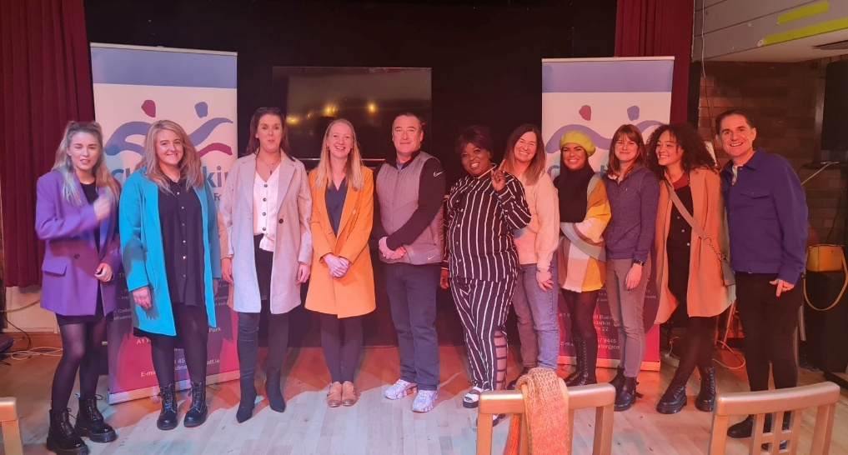Training and education are a large part of this work area. In 2022 the level 7 Addiction Studies programme took place. There was a completion rate of 16 from the 18 participants who took part. This programme has been updated over recent years and

Figure 19 Some of the Graduates from 2022 Level 7 Addiction Studies

provides additional access to other forms of training including, professional reflection/self-care, naloxone training and SAOR training. Other progression options have been developed including links to the Community Reps forum for instance. Many attendees on this course progressed to other educational and vocational roles.

A training schedule was developed as part of this work in 2022. Many needs were identified for training delivery including STORM training, SAOR training, cocaine specific and case management training.

Other training that was provided as part of this work theme in 2022 included SAOR training for the community. Twenty people received SAOR training in 2022. CDATF also funded four places on staff self-care training for funded project staff in 2022.

**T&R Group**

The T&R group met several times during 2022. The group added two new members in 2022 including the CDATF Service User Rep and the local HSE Suicide Resource Officer. There are a number of pieces of work involved in this subgroup that are outlined below. These are dual diagnosis, recovery and service user involvement.

**Dual Diagnosis**

In 2022 the T&R Subgroup prioritised work on dual diagnosis. This entailed revisiting and revising the memorandum of understanding between projects regarding this. A webinar was planned and delivered for Recovery Month 2022 that featured expert speakers discussing dual diagnosis and recovery. The CDATF Service User Rep took part in this event and shared his experience with service providers through the T&R group also.

Figure 20 Professor David Best Discusses Recovery Capital at CDATF Webinar 2022

**Recovery**

In 2022 the T&R group’s second priority was to focus on recovery. A calendar of events was planned for Recovery month in September 2022. These events included wellness and recovery events in services funded by CDATF, a webinar that had over 300 people registered and various local events. The Clondalkin Recovery Choir was established as an interagency pilot project between CDATF with the support of Station One. The choir is made up of people in recovery, family members of people in recovery and supporters of people in recovery. The choir took part in many events and raised awareness of recovery in Clondalkin and beyond. They took part in the Irish Recovery Academy’s recovery walk and festival in September 2022. Weekly Recovery Cafés were established by CASP and have continued since.

Figure 21 Clondalkin Recovery Choir

**Service User Involvement**

A Service User Rep joined the CDATF on a voluntary basis in 2021 and it was possible to provide some paid work for this person in 2022. A service user strategy was developed and is being re-drawn on a regular basis. The plan for this project is to develop better service user feedback mechanisms, develop a comprehensive Naloxone strategy for the area and include the voice of service users at subgroup and board level.

**SAFE**

In 2022 Strand Two funding for the SAFE initiative ended. The project was wound down over the course of this year and ceased in November 2022. The project was successful overall and achieved its primary goals of providing an interagency response to the issues of drug litter at transport hubs and helped focus on the increase in people visiting the area to purchase substances. Due to the pandemic this ceased to be as pressing an issue from 2020 onwards as restrictions on travel limited people visiting Clondalkin from other areas in the country. The project evolved in 2021 and 2022 to meet the need that presented and became a more standard outreach team that worked across Clondalkin and SW RDATF areas. There were significant numbers of outputs for this project in terms of number of harm reduction exchanges and interventions with very at-risk service users.

**7.3.4 Under 18s Summary**

In 2022 CDATF continued to work with Crosscare on the YDAP under 18’s initiative. This project aims to provide an evidence-based tier two community service for young people in the CDATF catchment. The project came fully under the remit of CDATF in December 2022 and will use CDATF planning and reporting systems from 2023 onwards.

In 2022 CDATF hired a person to work as YDAP coordinator to steer the project. The main focus of this role was to work to develop the team and ensure the use of evidence-based interventions. The coordinator also developed an engagement strategy for the project which involved negotiating the use of several spaces in the community as ‘satellite clinics’. This enables the project to meet young people as close as possible to where they live. The YDAP coordinator also performed a review of the service and commenced the development of a handbook based on this review to include a comprehensive suite of policy documents, caseload management templates and governance documents for the service. Finally plans were made to rebrand and relaunch the service in 2023.

Figure 22 YDAP Coordinator James Norman Presenting Presentation in Bridge House

In terms of outputs in 2022 37 young people accessed this service. There were 22 new referrals. Of these 20 received a comprehensive assessment. Due to the nature of this work family members are vital to its success and 16 families accessed YDAP for support in 2022. In all, there were 459 therapeutic consultations in the project in 2022.

**7.3.5 CDATF Workplan Detail**

|  |  |  |  |
| --- | --- | --- | --- |
| Lead and Work Descriptor | Local Drugs Strategy Goal | National Drugs Strategy Goal/Action | Outcomes in 2022 |
| **CDATF Rehabilitation**  **SAFE** | Goal 1  Dealing with the effects of drugs and alcohol misuse | Goal 2  Minimise the harms caused by the use and misuse of substances and promote rehabilitation and recovery  Action  2.2.28  Continue to expand Harm Reduction Initiatives focused on people who inject drugs. | Targeted service users received support and information about support and services in their local areas, harm reduction interventions and referrals as required. Reduction in drug litter and anti-social behaviour at the Fonthill train station and on the trains.  Members of the Steering Committee had increased knowledge and understanding of harm reduction and substance misuse issues.  Communication and information sharing was improved as a result of the relationships developed between Steering Committee members. Implementation of the SAFE Interim Review recommendations and overall improvement in service provision as a result. Following restructuring of SAFE outreach provision, the initiative went from having 1-2 part-time outreach workers to support the ACM, to having 4 part time outreach workers. This was achieved as a result of collaboration of resources between CTN, CASP, ARAS Kildare and the SWRDATF. |
| **CDATF Rehabilitation**  **T&R Subgroup** | Goal 3  Having a positive influence on mainstream services and contributing to more integrated responses | Goal 2  Minimise the harms caused by the use and misuse of substances and promote rehabilitation and recovery  Action  2.2.30  Continue to target a  reduction in drug related deaths and  non-fatal overdoses. | The T&R Subgroup’s priorities and actions were reviewed in line with the CDATF local area strategy and emerging needs identified in the community. The T&R Subgroup agreed priorities for the year and agreed a work plan. The new structure of the Subgroup has resulted in a more focused response and collaborative working towards addressing the issues emerging in the community.  The Subgroup responded to the needs of SUs in the community by prioritising emerging issues in the community, as reported by the Subgroup members. Members of the community and staff from CDATF projects have a collective understanding of the prominent issues facing SUs in the community.  Communication and interagency working was improved as a result of the relationships developed between Subgroup members. Subgroup members were more informed and involved in the work of the CDATF and local strategy.  Three local projects received T&R Grant money to deliver on additional programmes for SUs in the community. |
| **CDATF Rehabilitation**  **Service User Involvement** | Goal 2  Strengthening the role of the community in addressing the causes of drug and alcohol misuse. | Goal 4:  Support  participation of individuals, families  and communities  Action  4.2.44 Promote the participation of service users and their families, including those in recovery, in local, regional  and national decision making structures and  networks in order to  facilitate their involvement  in the design, planning and development of services and policies. | Meaningful progression opportunities were created for the SU Rep as a result of the development of the Volunteer role with the CDATF.  Role was developed in consultation with needs and interests of the SU Rep. SUs in the local area are supported by the volunteer SU Rep and had a voice through this new structure.  SU Rep was involved in TF structures such as T&R Subgroup and participated in the development of the local area strategy, specifically around the Dual Diagnosis and Recovery objectives.  Work of the CDATF was enhanced because of meaningful participation form the SU Rep.  Volunteer SU Rep was offered part time work in 2022 on back of successful involvement in CDATF work. |
| **CDATF Rehabilitation**  **Recovery** | Goal 1  Dealing with the effects of drugs and alcohol misuse | Goal 4:  Support  participation of individuals, families  and communities  Action  4.2.44 Promote the participation of service users and their families, including those in recovery, in local, regional  and national decision making structures and  networks in order to  facilitate their involvement  in the design, planning and development of services and policies. | Issues faced by people in recovery were responded to by the T&R Subgroup as a result of the prioritization of the issue, and gaps in the continuum of care were responded to.  People in recovery had meaningful progression opportunities in the local area. Members of the community and staff from CDATF projects increased their collective understanding of recovery.  Communication and information sharing was improved as a result of the relationships developed between members of the Subgroup working together on recovery initiatives. Membership of the T&R Subgroup was increased and includes those with expertise in recovery, including those working in the area, and those with lived experience. |
| **CDATF Rehabilitation**  **Dual Diagnosis** | Goal 1  Dealing with the effects of drugs and alcohol misuse | Goal 2: Minimise the  harms caused by the use and misuse  of substances and promote rehabilitation  and recovery  Action 2.1.18 Help individuals  affected by  substance misuse to  build their recovery  capital.  Action  2.1.17 Further strengthen  services to support  families affected by  substance misuse. | Issues faced by people experiencing DD were responded to by the T&R Subgroup because of the prioritization of the issue, and gaps in the continuum of care are being responded to.  People experiencing DD have meaningful progression opportunities in the local area. Members of the community and staff from CDATF projects have a collective understanding of issues facing people experiencing DD.  Members of the community and staff from CDATF projects have a clear understanding of the referral pathways and procedures for people experiencing DD.  Communication and information sharing is improved as a result of the relationships developed between members of the Subgroup. Membership of the T&R Subgroup has increased and now includes those with expertise of DD issues, including those working in the area, and those with lived experience.  People with lived experience participated in the Dual Recovery Webinar, shared their stories of dual recovery with their peers and the wider community, enhancing understanding of the issue. Better collaboration between mental health service and addiction support services as a result of relationships developed through engagement in T&R. |
| **CDATF Rehabilitation**  **Training**  **(Addiction Studies)**  **Other Training & Development – Training needs analysis for all CDATF funded projects and the Clondalkin Mental Health Services, commenced by Coordinator and T&R Officer. Training schedule developed for 2022.** | Goal 2  Strengthening the role of the community in addressing the causes of drug and alcohol misuse. | Goal 4:  Support  participation of individuals, families  and communities  Action  4.2.44 Promote the participation of service users and their families, including those in recovery, in local, regional  and national decision making structures and  networks in order to  facilitate their involvement  in the design, planning and development of services and policies. | 16 students (including members of the community and staff from CDATF projects & stakeholders) received the level 7 Certificate qualification in Addiction Studies from Maynooth University.  Individual outcomes for students -  4 students obtained employment in the sector (2 in the local area) after completing the Level 7. · 1 student was promoted to a senior position in current employment after completing the L7, and is now responsible for all harm reduction interventions, naloxone & overdose awareness.  5 students went on to further education in TBI (Traumatic Brain Injury), Leadership course, MI and CRA courses, Developmental Trauma training, Equality Studies in Maynooth University, Masters in Psychotherapy & Counselling with ICHAS. ·  2 students became involved in local community initiatives (Recovery Choir and Holistics with Station 1/Tus Nua).  9 students completed Naloxone training as an additional qualification offered as part of the Level 7 programme. This was organized by the CDATF SU Rep and facilitated by UICSE.  10 students (including 2 members of AGS) completed SAOR Screening & Brief Intervention training as an additional qualification offered as part of the Level 7, facilitated by CDATF staff.  All students completed a 1-day workshop on Professional Self-Care as part of the Level 7 programme. Members of the community and staff from CDATF projects & stakeholders have increased knowledge and understanding of substance misuse issues as a result of completing the course. TF project staff that have completed the course are upskilled and have knowledge of the NDRF which is a priority for working in addiction support services. Communication and information sharing has been improved as a result of the relationships developed between students and community members/staff from projects. Completing the course has provided pre-development education and capacity building for community members who wish to take a more active role in their community or go on to further education/employment.  Self Care Training – CDATF funded 4 places on Self Care Training for the Helping Professions run by Sandra Mullen in 2022.  Staff that attended the Self Care training feel better supported in their work and have acquired tools and skills they can use in order to better manage stress in the workplace.  Members of the community and staff from CDATF projects & stakeholders increased knowledge and understanding of substance misuse issues. TF project staff were upskilled as part of an ongoing commitment from the CDATF to support the professional and personal development of staff from local projects, community reps, SUs and other stakeholders. Collaboration, communication, and information sharing was improved as a result of the relationships developed between staff from the local projects, community members/reps and other stakeholders. |
|  |  |  |  |
| **CDATF Prevention**  **Schools** | Goal 1  Dealing with the effects of drugs and alcohol misuse | Goal 1  Promote and protect  health and wellbeing  Action  1.2.3 Support the SPHE  programme. | 3 Schools were supported to implement the EPI Model developed in 2021/22.  300 teachers engaged in education/information sessions around new and emerging drugs trends in Clondalkin.  Teaching staff can make more appropriate referrals to YDAP and Crosscare.  300 students engaged in an 8-week drug education/prevention course.  Issues were highlighted both through students and teachers about new and emerging trends e.g., Vaping.  The EPI model is the only model used by both the CDATF and Crosscare when working with schools around drug education and prevention.  Stakeholder consultation of key organizations occurred, and agreement achieved on goals of EPI. |
| **CDATF Prevention**  **YDAP Support** | Goal 1  Dealing with the effects of drugs and alcohol misuse | Goal 1 Promote and protect health and wellbeing.  1.2.5 Improve supports for young people at risk of early substance use. | A YDAP steering group was established to oversee this project and restructure it. Five meetings of this group took place in 2022. A terms of reference was drafted and new MOU for interagency working agreed also.  Training needs of the staff were identified, and training was delivered.  The workers now have a clear focus and direction for the project.  A model of care was finalised and allows for a more uniform approach in the CDATF area for young people.  Clarity was achieved for all organisations locally in relation to what the YDAP service can and will provide, this had led to more referrals particularly from schools.  Both workers were MI trained and now use this model with young people.  A record now exists to identifying gaps and blocks in existing services for young people to inform additional resource allocation in future.  The YDAP Co-Ordinator was employed and now works closely with the PO in school and informal school settings. |
| **CDATF Prevention**  **EPYC Sub-group** | Goal 3  Having a positive influence on mainstream services and contributing to more integrated responses | Goal 1 Promote and protect health and wellbeing  Action  1.2.5 Improve supports for young people at risk of early substance use. | This group continued to meet and evolve in 2022. The role of the group in garnering stakeholder views from the education, prevention, youth and community sectors in the area was strengthened.  Members of the community and staff from Com/Vol and Statutory services providers have had opportunity to increase knowledge and understanding of substance misuse issues for young people and their families.  The EPYC has provided opportunities for referral pathways to be improved by brining agencies together.  The workplan for the group was agreed at the start of the year and provided a basis for enhanced interagency collaboration. The workplan focused on young people’s involvement in criminality, DRI, the YDAP, mental health for local community, the EPI, a youth forum and emerging trends.  This group continued to monitor and feedback to CDATF on emerging trends and identify blocks or gaps in service provision locally. |
| **CDATF Prevention**  **Community Representatives** | Goal 2  To continue to strengthen the capacity of the community in challenging the root causes of drug and alcohol misuse including the harmful outcomes of drug policy, poverty  and inequality. | Goal 4: Support  participation of individuals, families  and communities  Action  4.1.39 Support and  promote community  participation in all  local, regional and  national structures. | Group has engaged in a group process to explore the impact and effect of drugs and alcohol on their communities.  Capacity was developed with a view to increasing their ability to contribute meaningfully to the work of the CDATF.  The group has successfully collaborated on the submission of a funding application to the Create Ireland (National Arts Council). |

**7.4 Funded Projects Achievements 2022**

|  |  |  |  |
| --- | --- | --- | --- |
| Lead and Work Descriptor | Local Drugs Strategy Goal | National Drugs Strategy Goal/Action | Outcomes in 2022 |
| **Carline Learning Centre** | Goal 1  Dealing with the effects of drugs and alcohol misuse | Goal 1 Promote and protect health and wellbeing  Action  1.2.5  Improve supports for young people at risk of early substance use. | During 2022, 30 students were supported and empowered to remain in education through the education and social care program at the learning centre. 15 Students successfully completed the Junior Certificate Cycle.  20% of the exiting students returned to mainstream education, 40% progressed to further educational opportunities and training programs and 5 students returned to PMVT Learning Centre- Carline to repeat their Junior certificate year as a result of the impact of COVID-19.  The 30 young people who attend Carline on a daily basis have experienced positive personal development. Some areas of personal development we focus on are anger management, developing positive coping strategies and developing personal goals and objectives set by the individual young person.  In 2020 the Learning Centre has worked with 43 young people, 38 male students and 5 female students. 8 of these students returned to the centre from the previous year. |
| **Neart Le Cheile** | Goal 2  Dealing with the effects of drugs and alcohol misuse | Goal 4  Support participation of individuals, families and communities.    Action  4.2.44  Promote the participation of service users and their families, including those in recovery, in local, regional and national decisionmaking structures and networks in order to facilitate their involvement in the design, planning and development of services and policies. | Cairdeas Advocacy service 19 people sought advocacy support in 2022 with a total of 53 advocacy actions. Most (17) had more than one issue to address with 5 people having over four issues. The advocacy was provided by staff funded through HSE Section 39. Many of these cases arose because of SUDS and Stepladder participation under section 39 Social Inclusion (Drug Task Force). At the beginning of the year people were supported by phone and Zoom but as the year progressed and the Stepladder course and SUDS group started meeting face to face work developed. · 12 people were male with 7 female · In terms of residence 10 live in North Clondalkin, 3 live in Southwest Clondalkin and 6 in Balgaddy.  Stepladder Training Course Stepladder Southwest Clondalkin Spring 2022 – After much consideration and with some restrictions and high cases of Covid we decided to run a small 6-week stepladder programme with 6 people in Southwest Clondalkin - This was felt the easiest way to protect everyone involved as well as others using the community centre in Bawnogue.  Due to lock down and staff working intermittently from home, it was also impossible to seek out participants through our usual advertising measure such as visiting services, clinics or sitting in on drop- ins with potential participants. Stepladder Southwest started on 12th of April 2022 and finished on Thursday 18th of May – with 6 participants.2 females (1 Southwest, 1 North Clondalkin) and 4 males (all North Clondalkin). The course covered 2 modules – The Steps Programme Tuesday & Thursday and Adult Literacy (Story Sacks) on Wednesday. Attendance on the course was exceptional for the 6 weeks – with two participants achieving full attendance. Having the smaller group allowed participants to work more closely together, however participants did express that would have liked to stay on longer. The course ended with a celebration lunch and presentation of certificates, followed by some short words of thanks and gratitude to all involved. Upon reviewing this programme with staff management and facilitators it was agreed that the 6-week programme wasn’t long enough for the participants to gain the necessary skills, confidence and tools to progress further with other training/ education or employment opportunities, so it was decided that these six participants would be offered a place on the 12-week programme in September 2022 along with 6 new participants. Stepladder North Clondalkin Winter 2022 The course commenced on 20th September and ended on the 8th of December with Eleven participants - (4 females (2 southwest Clondalkin) – 7 males (1 – Clondalkin Village & 7 North Clondalkin). In week two one participant dropped out as she secured a place in residential treatment. The course consisted of 4 modules - 12 weekly sessions on the Steps Programme (Tuesday) - 6 weekly sessions on Literacy Art (Wednesday), 6 weekly sessions on WRAP (Wellness Recovery Action Programme)- facilitated and delivered by Laura Peel – Cumas Family Support Worker and 12 weekly sessions on Personal Interpersonal Skills through the Adult Learning Centre - A total of 36 sessions over 12 weeks (3 mornings per week). Attendance daily on this group was also exceptional with two participants achieving full attendance for the 12-week duration. One Female participant was put off the course on week nine due to addiction issues and absences. The group were taken on a trip to the local library on one of the days and some became members. This was a great experience as participants are not always aware of or don’t always avail of other services /amenities in the local area. In general, the programme was hugely successful, with participants asking for follow up session in 2023 on specific things such as preparing your CV, welfare rights, training opportunities in the local area such as Aras Rualach. This will be planned by Lisa in 2023 and members will be contacted. Again, the progression onto farther education/ training or employment at the end of Stepladder is a barrier for various reasons such as lack of childcare, inability to access due to social welfare payment type or funding etc. From this programme 5 participants have joined and attend the SUDS group (Service Users Developing Solidarity) weekly on a Tuesday Evening  Service Users Developing Solidarity (SUDS) SUDS: In February 2022 – post Covid - SUDs restarted as a weekly meeting group in house. There were seven people attending on a regular basis - two old members and 5 new members, who came through Stepladder and word of mouth. By the end of 2022, there was still six fully active members each week, with one moving to one-to-one support with a view to re- attending at some point in 2023.  Cumas is a community-based service, which works with families affected by drug use. In 2022 we worked with 41 families and several people in some families giving a total of 54 people. Individuals were seen in various capacities; individual, group, family sessions and home visits with family. The families engaging with Cumas would be placed within the Hardiker Model at levels two, three and four. It is noticeable that families would more often be classified as a 3 rather than a 2 and the number of families who are at risk and on the Child Protection Notification System has increased. |
| **YDAP** | Goal 1  Dealing with the effects of drugs and alcohol misuse | Goal 2  Minimise the harms caused by the use and misuse of substances and promote rehabilitation and recovery  Action  2.1.22  Expand the range,  availability and  geographical spread  of problem drug and  alcohol services for  those under the age of  18. | In 2022 CDATF hired a person to work as YDAP coordinator to steer the project. The focus of this role was to work to develop the team and ensure the use of evidence-based interventions. The coordinator also developed an engagement strategy for the project which involved negotiating the use of several spaces in the area as ‘satellite clinics’. This enables the project to meet young people as close as possible to where they live. The coordinator also performed a review of the service and commenced the development of a handbook based on this review to include a comprehensive suite of policy documents, caseload management templates and governance documents for the service. Finally plans were made to rebrand and relaunch the service in 2023.  In terms of outputs in 2022 37 young people accessed this service. There were 22 new referrals. Of these 20 received a comprehensive assessment. Due to the nature of this work family members are vital to its success and 16 families accessed YDAP for support in 2022. In all, there were 459 therapeutic consultations in the project in 2022. |
| **Clondalkin Tus Nua & Station One** | Goal 1  Dealing with the effects of drugs and alcohol misuse | Goal 2  Minimise the  harms caused by the use and misuse  of substances and promote rehabilitation  and recovery  Action  2.1.18 Help individuals  affected by  substance misuse to  build their recovery  capital. | **Open Access Contact /Drop In:**  Individual attendances for Drop-in Supports: 693  **Homeless Provisions**: ·  Tent’s 27 · Sleeping bags 356 · Clothes 68 · Food (small food bags) 321 · Food hampers 154.  **Outreach / Harm Reduction / NSP Service**:  Harm Reduction/ Brief/Crisis Interventions Sessions: 187 Total Number of NSP Provided: 505 ·  Foil 34 ·  Needle packs 271 ·  Crack pipes 200  **Addiction / Substance Use Support Services**  Number of services users accessing Assessment: 164  One to One session Provided: 1147  Key working Sessions: 679  Crisis / Brief Interventions: 304  Assessment / Initial contact Screening:164  Phone/ Zoom interventions: 91  **Station 1 Rehabilitation Programme**:  **Service Users Availed of Services in Station 1 Rehabilitation Programme: 48**  Pre programme induction supports: 36 ·   * Service Users referred on to Drug Free Programme:5 · Service Users referred on to Stabilisation Programme / pre detox supports: 17 · * Service Users referred on to P5 aftercare support: 4 · Service Users felt treatment was complete after shot-term interventions(4-12weeks): 13 · * Service Users ceased contact and follow up could not be arranged: 10.   P2 Recovery Preparation: 6 ·   * Service Users were referred to residential treatment / detox: 2 · * Service Users currently working on referral for Tier 4: 1 · Service User community detox: 0 · * Service Users were referred to P3 Drug Free Programme: 3   P3 Drug & Alcohol-Free Programme: 14 ·   * Service Users progressed into full-time employment: 3 · * Participant progressed to educational programme: 0 · * Service Users progressed onto P4 Progression and Integration Pathways ACE Programme: 0 · * Service Users attending part-time 3rd level educational courses in addiction: 4.   P4 Progression and Integration Pathways ACE Programme: xx·   * Service Users progressed to employment: 4 · * Service User have moved to mainstream community employment: xx · * Service Users have gained part-time employment: 5.   P5 Aftercare: 6 ·   * Service Users accessed aftercare supports in Station 1 this included key one to one, referrals for additional supports, brief and crisis interventions, counselling and evening group meditation: 6.   In house group interventions provided in 2022 ·   * Weekly Therapeutic Peer Process Group· * Straight Ahead Group Recovery Programme · * Building Recovery Skills · * Reduce the Use Group · * Cognitive Behavioural Skills Group · * Stress Management · * Aromatherapy · * Crafts workshops · * Meditation · * Relapse Prevention Skills Group · * Addiction Awareness Workshops · * Yoga · * Art · * Self-Care and Wellbeing · * Life Skills and Social Development |
| **Clondalkin Tus Nua**  **(Family Support)** | Goal 1  Dealing with the effects of drugs and alcohol misuse | Goal 2  Minimise the  harms caused by the use and misuse  of substances and promote rehabilitation  and recovery  Action  2.1.17 Further strengthen services to support families affected by substance misuse. | **Family Support:**  Family Support:   * Individual Family Support One to One Interventions: 205 · Crisis Interventions: 28 · * Individual availed of one-to-one support sessions: 61. * New services users: 33 · * Family Support Group attendance: 258   **Counselling**:· One to One Counselling Sessions: 212 |
| **Clondalkin Youth Services** | Goal 1  Dealing with the effects of drugs and alcohol misuse | Goal 1 Promote and protect health and wellbeing.  Action  1.2.5 Improve supports for young people at risk of early substance use. | 1. During the year staff engaged with young people that had been referred through TUSLA, School Completion Referrals, probation, internal referrals within the youth service and through outreach. This enabled staff to build links with young people in the youth service, particularly those most in need and at risk of alcohol and substance misuse. Staff encouraged young people to engage in our various programmes run within the youth service. Staff also worked closely with the Youth Drug & Alcohol Project (Y-DAP) in the youth service in Clondalkin, in the first 6-8 months of the year, before the Y-DAP team leader joined CDATF.  2. The project provided a range of afternoon and evening activities and interventions to groups and individuals through one to one and small groupwork and focused on building relationships with the young people to better respond to their emerging needs. Through a variety of interventions and programmes young people were supported and enabled to make positive life choices and realise their potential. Staff worked with young people during the year who are suspected of holding and carrying drugs in the area. Staff had identified some young people they would be concerned with who have drug issues and are known to have links to drug dealers in the community. Employment and education were a major issue of concern during the year, and young people were offered support in training and community work. Staff supported some young people to reduce their alcohol and drug usage. Referrals were also made to appropriate services in the community to help them with their mental health and young people were signposted and supported to engage in other services.  3. From September 2022 staff worked alongside the CDATF Prevention Officer and another Prevention worker (based in Ronanstown youth service) to roll out the delivery of an evidence-based drug and alcohol programme in three schools across the CDATF catchment area. This programme focuses on developing and building on the young people’s knowledge and resilience to assist them in making more positive life choices especially in relation to drugs and alcohol. The programme runs for approx. 12 weeks in 2022 with a one-hour session in three schools each week. The programme will continue to run through to the end of the 2022/2023 academic year. The programme will be reviewed at that point. The prevention workers have played a key role in supporting the roll out of this programme which has been identified as a key objective by CDATF. |
| **Ronanstown Youth Service** | Goal 1  Dealing with the effects of drugs and alcohol misuse | Goal 1 Promote and protect health and wellbeing.  Action  1.2.5 Improve supports for young people at risk of early substance use. | **Prevention Worker**  1.Education and Prevention TY group program in three schools Adamstown , Kishouge and Collinstown Community Schools across the catchment area working to reduce the risk and harm of drugs and alcohol on a young person’s life by encouraging young people to develop the skills and confidence to deal with the complications in their lives and to provide pathways to appropriate interventions, supports and services to enable the young person to live a healthier and happier life and encouraging and promoting personal responsibility for the life choices young people make, dispelling myths and providing a learning space for the most relevant and up to date information in a variety of ways including group discussion , individual reflection, identifying key areas of concern for the young people and the impact substance use and misuse can have on themselves , their families and the community. . The programme worked with young people in the (14 to 16) age group  2. Monday Group is made of 7 young people who have been referred to the youth service by School Completion and the Home School Liaison Officer a number of the group come from homes impacted by substance use, homelessness, parental separation, violence and extreme trauma. The program is in its second year and supports the transition of the young people into second level education, the program includes personal development, staying safe and preventive education. One of the group was referred by staff to Play Therapy for extreme anxiety and another young person is receiving a myriad of additional supports due to the trauma in their lives. Another in the group has separation issues and rarely sees their mother who has had issues with substances which has effected them deeply the group is a safe haven and a space for the young people to learn and grow and where staff highlight the benefits of education and life- long learning.  **Family Intervention**  1. Children/Young people at risk and their families  Parents and a lot younger people 18 to 21 availed of mindfulness and stress management sessions particularly coming up to exams, we provided families support around issues such as mental health for young people and their families. Three retreat days was organised to Glendalough for families, providing a real break for families going though difficulties we also had five wellness days for the mothers of the families. There were a few cases this year where there were violent incidents witnessed by children, so a lot of extra support was provided to those families ensuring the children were referred on for specialist care for trauma. Personal Development work continued with the parents providing them with tools to use for themselves and in their parenting and our peer support group continued to be a lifeline for some isolated and vulnerable parents.  2. Young Drug Users under 18  Successfully worked with parents of young people engaged in drug use and drug dealing and families who were experiencing drug intimidation and huge drug debts, who were engaged in drug use ranging from cannabis use only to poly drug use who were not attending school. Over a few months of working with parents we were able to work through specific areas with parents such as being more assertive, keeping safe, being consistent, positive parenting and communication skills. We also worked with 2 families where there was a threat to life with one family having to go homeless and lose their council house. Working with the parents usually just the mother in most cases family support work encouraged and mentored positive consistent parental behaviours for change such as being more assertive, putting safety precautions in place, being consistent, positive parenting and communication skills. The parents also engaged in peer support, mindfulness sessions and holistic therapies which supported them in becoming more confident in their role and being more proactive and engaging with other services such as the Schools, Education Welfare Officers, Garda, JLO’s, Youth Justice Workers, CAHMS. Tusla.  3. Families of Drug Users  Continued to provide support, advice, and information to families of drug users enabling and encouraging them to link into specialised services for support around specific issues such as mental health, addiction and drug intimidation. |
| **CASP** | Goal 1  Dealing with the effects of drugs and alcohol misuse | Goal 2  Minimise the  harms caused by the use and misuse of substances and promote rehabilitation.  and recovery  Action  2.1.13 Expand the  availability and  geographical  spread of relevant  quality drug and  alcohol services and  improve the range  of services available,  based on identified  need. | **Drop-In Services**:  CASP provided 10 drop-in sessions per week which totalled 1485 actions including food, showers, and laundry for service users. 151 people availed of this service in 2022.  **Needle Exchange**:  There were 743 exchanges made to 164 people in 2022.  **Recovery Café**:  CASP hosted two recovery cafes per week from March to December. 55 people in total availed of this service.  **Group Work**:  A women’s group met 27 times between November 2021 and April 2022. Eight women availed of this group.  **Family Support Service**:  There were 1022 individual support sessions for family members in 2022. These sessions were provided to 85 family members.  **Family Support Group Work:**  6 sessions of meditation group.  6 sessions of Monday morning group.  27 sessions of Friday evening group  7 sessions of peer support group  22 sessions of Tuesday evening drop in  **Counselling Services:**  1987 Counselling sessions were provided to 147 clients in 2022.  26 Group counselling sessions were provided to 16 clients in 2022. |
| **CASP**  **Prison Links** | Goal 1  Dealing with the effects of drugs and alcohol misuse | Goal 2  Minimise the  harms caused by the use and misuse  of substances and promote rehabilitation  and recovery  Action  2.1.13 Expand the  availability and  geographical  spread of relevant  quality drug and  alcohol services and  improve the range  of services available,  based on identified  need. | I. From January 2nd, 2022, to date, the CPL Worker had 242 interventions with 47 clients.  2. 15 clients were referred to education. 12 clients were referred to prison counselling services. 1 client is beginning her second year in college post release.  3. The CASP CPL Worker has worked to develop links with changing prison staff, with staff of Probation, TEOs and ISM Service. 2 presentations on the work of the CPL Worker were made to prison staff in 2022. |
| **CTDG** | Goal 1  Dealing with the effects of drugs and alcohol misuse | Goal 2  Minimise the  harms caused by the use and misuse  of substances and promote rehabilitation  and recovery  Action 2.1.27  Improve the  capacity of services  to accommodate  the needs of  people who use  drugs and alcohol  from specific  communities  including  the Traveller  community;  the lesbian,  gay, bisexual,  transgender and  intersex community;  new communities;  sex workers and  homeless people. | The traveller substance use worker post was vacant for much of 2022. CTDG, in collaboration with the CDATF took this opportunity to re-focus the role. The position was filled in January 2023. The revised role and workplan is outlined below.    *Change of title to Drugs and Alcohol Case Manager.  After much discussion with management and staff of CDATF we agreed that the main areas of work that the Drugs  and Alcohol Case Manager would undertake would be:  *To address the needs of Travellers who are engage with or at risk of alcohol and substance misuse.  To proactively engage with Travellers experiencing substance misuse issues and to link individuals to the most  appropriate services/supports in the areas and to facilitate that referral pathway.  *To work in conjunction with local drug services to develop strategies to improve accessibility for members of the  Traveller Community.  *To link Travellers with mainstream drug and alcohol services and to  *Identify any gaps and blocks to Travellers using mainstream supports and to work appropriately with the service  providers to help remove these blocks.  *To provide appropriate education programmes to young Travellers identified as being "at risk" of engagement in  drug and alcohol misuse.  *To develop and deliver a range of programmes aimed at the Traveller community with a focus on prevention |
| **Community Safety Forum** |  | Goal 4. Support participation of individuals, families and communities.  Action 4.1.41  Enhance the  relationship  between an Garda  Síochána and  local communities  in relation to the  impact of the drugs  trade. | **South Western Area Community Safety Forum**  1. We commenced our face-to-face meetings in May 2022. There were 10 CSF meetings in 2022, these meetings were attended by local residents from a broad number of housing estates, local authority and private, AGS and SDCC. The Forum dealt with many issues throughout the year, such as vandalism, ASB, drug dealing& intimidation, and dumping. The CSF members also participated in the consultation process for the development of St. Cuthberts Park.  The CSF organised an outdoor movie event for Culture Night September 2023 in St. Cuthbert’s Park, due to the success of this event we are considering repeating it next year.  **North Clondalkin Community Safety Forum**  1. Attendance at CSF meetings from the community, local agencies and statutory agencies has been consistent throughout the year, however community representation and participation still need to be increased and supported/developed.  Ongoing support has been provided to Balgaddy residents on various issues and we continue to support the Balgaddy representative on the CSF and LPF.  2. Coordination and support provided to the Community Safety Forum and Local Policing Forum.  Residents worked to reduce dumping in the area and organised monthly clean ups.  We supported Balgaddy Residents Association to hold some outdoor and indoor events in summer and at Halloween, we also organised a smaller Halloween festival in North Clondalkin. The capacity of these events were much smaller than other years as we had to adhere to Covid guidelines  3. Participation from local agency and service users has improved and we will continue to ensure further improvement on this  We will also use other methods to engage with the community and local agencies to address issues of community safety in 2022 in line Covid guidelines. |

**8 Board Membership 2022**

|  |  |
| --- | --- |
| Name | Representation |
| Pat Bennett | Chairperson |
| Noreen Byrne | Vice Chairperson |
| Ann Corrigan | Voluntary Representative |
| Emily Smartt | Voluntary Representative |
| Maria Finn | Voluntary Representative |
| Rosie McGlone | Voluntary Representative |
| William Carey | Public Representative |
| Eoin O’Broin | Public Representative |
| Madeleine Johansson | Public Representative |
| Sheilann Monaghan | Voluntary Representative |
| Eddie Mullins | Statutory Representative (Prisons Service) |
| Pat Conway | Statutory Representative (HSE) |
| Inspector Liam Casey | Statutory Representative (An Garda Siochana) |
| Jonathan Hayden | Statutory Representative (SDCC) |
| Grainne Finnegan | Statutory Representative (TUSLA) (resigned 2022) |
| Tiernan Heaney | Voluntary Representative (resigned 2022) |

**9 Appendices**

**Appendix A References**

1. Wright M. The Dublin Region: Advisory Regional Plan and Final Report: Part One: GPSO; 1966.

2. Council SDC. 2018.

3. CDATF. CDATF Annual Report 2019. 2020.

4. Office CS. Census 1991.

5. CODAN.

6. Dean G, O'Hare A, O'Connor A, Kelly M, Kelly G. The" opiate epidemic" in Dublin: are we over the worst? Irish medical journal. 1987;80(5):139-42.

7. O’Gorman A, editor Illicit drug use in Dublin. Illicit drug use in Europe, Proceedings of the Seventh Annual Conference on Drug Use and Drug Policy, Amsterdam Amsterdam; 1997.

8. Butler S. Rabbitte revisited: the First Report of the Ministerial Task Force on Measures to Reduce Demand for Drugs-ten years on. ADMINISTRATION-DUBLIN-. 2007;55(3):125.

9. O’Gorman A, Driscoll A, Moore K, Roantree D. Outcomes: Drug harms, policy harms, poverty and inequality. Dublin: Clondalkin Drug and Alcohol Task Force. 2016.

10. CSO. 2016 Census 2017.

11. CDATF. CDATF Local Drugs Strategy 2018-2025. 2018.

12. Reducing Harm, Supporting Recovery: A Health-led Response to Drug and Alcohol Use in Ireland 2017-2025: Irish Department of Health; 2017.

13. SDCC. South Dublin Local Economic and Community Plan. 2016.

14. Pratschke THJ. The 2016 Pobal HP Deprivation Index for Small Areas (SA)

15. SDCCPPN. SDCCPPN Poverty Map. 2020.

16. CYPSC. South Dublin Children and Young People's Services Committee Evidence Baseline Report, 2017. . 2017.

17. HRB. NDTRS Treatment Data 2021 Clondalkin. 2022.

18. HRB. NDTRS Treatment Data 2020.

19. HRB. Irish National Drugs and Alcohol Survey. 2020.

20. Solutions BI. Interim Review CDATF Strategic Plan 2018-2025. 2022.

21. O'Heaire G. Cracking on: a harm reduction report. Dublin: The Bawnogue Youth and Family Support Group. 2013.

22. Ward M. TD Says Canal Drug Dealing "Getting Out Of Hand" after Crack Cocaine Found In Tent. 2021.

23. Force TDT. Crack Now the Most Problematic Substance. The Echo Newspaper. 2021.

24. Cocaine RIBC. 2021.

25. HRB. Irish National Drug and Alcohol Survey 2020. 2021.

26. Baker N. ‘Under the counter’ vapes found to contain cannabis: Irish Examiner; [Available from: <https://www.irishexaminer.com/news/arid-40947146.html#:~:text=Denis%20Murray%2C%20one%20of%20the,THC)%20%E2%80%94%20a%20controlled%20drug>.

**Appendix B Strategic Plan Implementation Table 2022-2025**

**7.1 NDS Priority One**

|  |  |  |  |
| --- | --- | --- | --- |
| **Strengthen the prevention of drug and alcohol use and the associated harms among children and young people** | | | |
| **Action** | **Lead/Partner** | **Timeline** | **Outcomes** |
| 1.Pilot the Education Prevention Intervention Team (EPIT) as an enhanced area-based prevention approach targeting the 4P’s (Parents, Pupils, Policy, and Professionals) | EPYC (Lead) with YDAP & Crosscare as partners | Pilot in 2022  Ongoing review with aspiration that it is  mainstream provision by 2025 | -Piloting of the EPIT  -Improved mental health and well-being of YP  -Young People progress and achieve in education  -Strengthening Social Personal & Health Education (SPHE) supports to schools in CDATF area  -Improved family relationships  -Increased awareness of and stronger resilience to the harms of drugs and alcohol in schools  -Improved inter-agency working  -More effective targeting of at-risk young people |
| 2.Review membership of local, county, and regional committees to maximise CDATF influence in prevention policy and strategy (CYPSC, JPC, LDC, YPAR, PPN) | TF | End of 2022 and  Annually thereafter | -A written Review which provides basis for below.  -CDATF to have increased influence in key policy forums  -CDATF to have better insights into wider strategy and policy development  -A greater awareness of CDATF across their area |
| 3.Promote access to parenting and family programmes for services engaging with high-risk families | EPYC & TF Projects | Ongoing | -Improved access to Strengthening Family, Parents Under Pressure (PUP) and Triple P programmes  -Improved parenting  -Stronger family units and enhanced prevention |
| 4. Strengthen the sustainability of YDAP | YDAP (Lead) with CLDATF & Crosscare | 2023 | -YDAP Sustainability  -Enhanced YPAD infrastructure  -Enhanced U18 inter-agency working |

**7.3 NDS Priority Two**

|  |  |  |  |
| --- | --- | --- | --- |
| **Enhance access to and delivery of drug and alcohol service in the community** | | | |
| **Action** | **Lead/Partners** | **Timeline** | **Outcomes** |
| 5.Provide person-centred supports and effective service responses to the needs of those affected by drug and alcohol misuse | CASP, Tus Nua, Neart Le Cheile, YDAP, CTDG | Ongoing | -Improved access to CLDATF funded services  -Changed relationship with drug/s of choice (Stabilisation, reduced use, drug free)  -Achievement of care plan goals |
| 6.Increase meaningful progression opportunities (aftercare, community integration) and champion a culture of dual recovery across all services | CASP, Tus Nua, EPYC, T&R | Ongoing | -Improved progression opportunities  -More Recovery options (Café & Choir)  -Increased Recovery Capital  -Improved Rehabilitation  -Increased access to educational opportunities |
| 7.Implementation of the National Drug Rehabilitation Framework (NDRF) | Treatment & Rehabilitation Officer (T&RO)  All CDATF funded projects | Ongoing and reviewed annually | **-**Increased capacity among services for NDRF implementation  **-**Improved inter agency working  -Enhanced access to services  **-**Greater alignment with current policy (Slaintecare) |
| 8.Enhance and develop community-based alcohol programmes | T&R | 2024 | -Improved knowledge of community-based alcohol programmes  **-**Improved access for people requiring support for alcohol misuse |

**7.4 NDS Priority Three**

|  |  |  |  |
| --- | --- | --- | --- |
| **Develop integrated care pathways for high-risk drug users to achieve better health outcomes** | | | |
| **Action** | **Lead/Partners** | **Timeline** | **Outcomes** |
| 9.Apply the NDRF model to develop integrated care pathways (inter agency, outreach, street work, prisons) for the defined high-risk user | T&R/RO | Ongoing | -Improved integrated care pathways for high-risk drug users in the CDATF area  -Increased access to hard-to-reach people impacted by substance misuse  -Improved engagement with the travelling community and ethnic minorities  -Reduced mortality due to substance misuse  -Reduced homelessness  -Reduced exploitation  -Improved health & well-being  -Achievement of care plan goals |

**7.5 NDS Priority Four**

|  |  |  |  |
| --- | --- | --- | --- |
| **Address the social determinants and consequences of drug use in disadvantaged communities** | | | |
| **Action** | **Lead/Partners** | **Timeline** | **Outcomes** |
| 10.Strengthen the voice of the community through ensuring area wide representation on the CDATF community reps forum and service user involvement | EPYC/PO & CDATF Projects | Ongoing | **-**Stronger community voice on social determinants and consequences  **-**Enhanced progression opportunities for the community  -Increased Community representation on the CDATF Board  -Improved service user involvement  -Better understanding of service user needs  -Enhanced collaboration between projects |
| 11.Engage with key stakeholders to facilitate their renewed commitment to the DATF model of community-based partnership through active participation on CDATF Board and committees | CDATF Board | Ongoing | -More effective and representative CDATF Board  -Meaningful Involvement in strategy development and review  -Restructuring of sub committees |
| 12.Respond to Drug Related Intimidation (DRI) in the CDATF area | EPYC, YDAP, CTN (Tus Nua) Gardai, CASP, Community Safety Forum | 2022 and Ongoing | -Implement DRIVE framework  -Reduced Intimidation  -Improved community policing  -Improved community safety |

**7.6 NDS Priority Five**

|  |  |  |  |
| --- | --- | --- | --- |
| **Promote alternatives to coercive sanctions for drug-related offences** | | | |
| **Action** | **Lead/Partners** | **Timeline** | **Outcomes** |
| 13.Provide a mechanism to engage all CDATF stakeholders on the decriminalisation debate and articulate the findings | CDATF | 2023 | -Improved community involvement  -Shared understanding  -Cohesive approach  -Improved stakeholder engagement |

**7.7 NDS Priority Six**

|  |  |  |  |
| --- | --- | --- | --- |
| **Strengthen evidence-informed and outcomes-focused practice, services, policies, and strategy implementation** | | | |
| **Action** | **Lead/Partners** | **Timeline** | **Outcomes** |
| 14.Set out research and evaluation requirements for the period 2022-25.   1. Quantify the needs of Young People in the CDATF area (How many accessing Jigsaw, how many on waiting list for CAMHS and YDAP, what additional needs are presenting)      1. Explore new and emerging trends (including drug of choice, high risk groups, socio-economic profiles, ethnic origin) through a reporting template that can be updated quarterly 2. Community impact analysis of projected population growth to inform a submission to the County Development Plan 3. Research the impact of “cautions” did they continue to use after the caution 4. Continue to highlight the vulnerability of young people to manipulation by criminal gangs and involvement in the drugs economy 5. Identify the extent of core underfunding of TF services | CDATF Board EPYC, T&R, | Annually commencing 2022  Ongoing  Baseline template in place by end of 2022  2023  2024  Ongoing  2023 | -Increased production of high-quality research and evaluation  -Defined areas of research for TF to work on  -Strengthened evidenced informed interventions  -Improved inter-agency working  -Increased efficiency in service delivery  -More effective targeting of at-risk young people  -Improved access to and understanding of high-risk groups  -Enhanced understanding of need in the CDATF area  -Improved understanding of the social determinants of drug use in the CDATF area  -Increased understanding of future population growth in CDATF  -Enhanced business case for future funding  -Stronger evidence base to inform the decriminalisation debate  -Improved understanding among policy makers and judiciary in relation to the vulnerability of young people  **-**Enhanced business case for funding increase |
| **Action** | **Lead/Partners** | **Timeline** | **Outcomes** |
| 15.Agree reporting template (Outputs, Outcomes, and Indicators) for the CLDATF Strategic Plan 22-25 | EPYC, T&R, TF | End of 2022 for SLA meetings and annually thereafter | -Improved impact measurement  -Improved Performance Measurement  -Improved strategy implementation  -Enhanced evaluation across all CDATF services |
| 16.Continue to work with all funded services to address data collection challenges | EPYC, T&R, TF | Ongoing | -Improved data collection  -Stronger evidencing of need  -Increased capacity to demonstrate value for money |
| 17.Use the CDATF strategy as a framework for every partner to agree and evaluate collective effort. | CDATF and funded projects | Ongoing | -Improved partnership working  -More cohesive strategy |
| 18.CDATF to support compliance with relevant regulatory bodies (CRA, CRO, HSE) | CDATF Board | Ongoing | -Improved compliance against regulatory and statutory standards  -Best practice policies and procedures |
| 19.Support CDATF and funded services with implementation of the National Standards for Safer Better Healthcare | CDATF | By 2023 | -Improved compliance against regulatory and statutory standards  -Best practice policies and procedures |
| 20.CDATF to oversee the creation of a repository of generic policies and procedures which services can access to facilitate compliance against regulatory and national standards. | CDATF, Staff finance & governance subgroup | 2023 | -Improved collaboration among all CDATF funded services  - Improved compliance against regulatory and statutory standards |

**Appendix C CDATF Strategic Plan Outcomes 2022**

|  |  |  |  |  |
| --- | --- | --- | --- | --- |
| **Strengthen the prevention of drug and alcohol use and the associated harms among children and young people** | | | |  |
| **Action** | **Lead/Partner** | **Timeline** | **Outcomes** | **Progress 2022** |
| 1.Pilot the Education Prevention Intervention Team (EPIT) as an enhanced area-based prevention approach targeting the 4P’s (Parents, Pupils, Policy, and Professionals) | EPYC (Lead) with YDAP & Crosscare as partners | Pilot in 2022  Ongoing review with aspiration that it is Mainstream provision by 2025 | 1.1-Piloting of the EPIT  1.2 Improved mental health and well-being of YP  1.3 Young People progress and achieve in education  1.4 Strengthening Social Personal & Health Education (SPHE) supports to schools in CDATF area  1.5 Improved family relationships  1.6 Increased awareness of and stronger resilience to the harms of drugs and alcohol in schools  1.7 Improved inter-agency working  1.8 More effective targeting of at-risk young people | 1.1 EPIT in pilot phase  1.2 Not Measured, longer term goal  1.3 Not Measured, longer term goal  1.4 Strengthened SPHE supports provided to 3 schools.  1.5 Not Measured, longer term goal.  1.6 Initial feedback positive from school.  1.7 EPIT has provided stronger basis for interagency working.  1.8 Some referrals filtering in from schools. |
| 2.Review membership of local, county, and regional committees to maximise CDATF influence in prevention policy and strategy (CYPSC, JPC, LDC, YPAR, PPN) | TF | End of 2022 and  Annually thereafter | 2.1 A written Review which provides basis for below.  2.2 CDATF to have increased influence in key policy forums  2.3 CDATF to have better insights into wider strategy and policy development  2.4 A greater awareness of CDATF across their area | 2.1 Currently Being Drafted  2.2 Depending on review see above  2.3 Depending on review see above  2.4 Depending on review see above |
| 3.Promote access to parenting and family programmes for services engaging with high-risk families | EPYC & TF Projects | Ongoing | 3.1 Improved access to Strengthening Family, Parents Under Pressure (PUP) and Triple P programmes  3.2 Improved parenting  3.3 Stronger family units and enhanced prevention | 3.1 No Progress-  3.2 No Progress  3.3 No Progress-- |
| 4. Strengthen the sustainability of YDAP | YDAP (Lead) with CLDATF & Crosscare | 2023 | 4.1 YDAP Sustainability  4.2 Enhanced YPAD infrastructure  4.3 Enhanced U18 inter-agency working | 4.1 Substantial work carried out. Transition to TF.  4.2 Hiring of Coordinator, development of management group.  4.3 Crosscare, HSE, TF part of management group and oversaw delivery of YDAP service in 2022.  Working well with EPIT and EPYC subgroup. |

|  |  |  |  |  |
| --- | --- | --- | --- | --- |
| **Enhance access to and delivery of drug and alcohol service in the community** | | | |  |
| **Action** | **Lead/Partners** | **Timeline** | **Outcomes** | **Progress 2022** |
| 5.Provide person-centred supports and effective service responses to the needs of those affected by drug and alcohol misuse | CASP, Tus Nua, Neart Le Cheile, YDAP, CTDG | Ongoing | 5.1 Improved access to CLDATF funded services  5.2 Changed relationship with drug/s of choice (Stabilisation, reduced use, drug free)  5.3 Achievement of care plan goals | 5.1 CDATF provided funding for service open days and promotional videos.  5.2 Ongoing work, needs additional input from services and cross referencing with SA  5.3 Ongoing work, needs additional input from services and cross referencing with SA |
| 6.Increase meaningful progression opportunities (aftercare, community integration) and champion a culture of dual recovery across all services | CASP, Tus Nua, EPYC, T&R | Ongoing | 6.1 Improved progression opportunities  6.2 More Recovery options  6.3 Increased Recovery Capital  6.4 Improved Rehabilitation  6.5 Increased access to educational opportunities | 6.1 See project SA/outcomes framework  6.2 Focus on Recovery has resulted in establishment of recovery cafes in services and recovery choir.  6.3 Not measured.  6.4 See project SA/outcomes framework.  6.5 Reduction of addiction studies fee for most in need has resulted in greater uptake. |
| 7.Implementation of the National Drug Rehabilitation Framework (NDRF) | Treatment & Rehabilitation Officer (T&RO)  All CDATF funded projects | Ongoing and reviewed annually | 7.1 Increased capacity among services for NDRF implementation  7.2 Improved inter agency working  7.3 Enhanced access to services  7.4 Greater alignment with current policy (Slaintecare) | 7.1 YDAP has undertaken training in NDRF training. A need has been identified in services for training on this.  7.2 Relaunch of T&R subgroup , Recovery Month well supported.  7.3 Not measured.  7.4 Requires review against slaintecare. |
| 8.Enhance and develop community-based alcohol programmes | T&R | 2024 | 8.1 Improved knowledge of community-based alcohol programmes  8.2 Improved access for people requiring support for alcohol misuse | 8.1 No progress  8.2 No progress |

|  |  |  |  |  |
| --- | --- | --- | --- | --- |
| **Develop integrated care pathways for high-risk drug users to achieve better health outcomes** | | | |  |
| **Action** | **Lead/Partners** | **Timeline** | **Outcomes** | **Progress 2022** |
| 9.Apply the NDRF model to develop integrated care pathways (inter agency, outreach, street work, prisons) for the defined high-risk user | T&R/RO | Ongoing | 9.1 Improved integrated care pathways for high-risk drug users in the CDATF area  9.2 Increased access to hard to reach people impacted by substance misuse  9.3 Improved engagement with the travelling community and ethnic minorities  9.4 Reduced mortality due to substance misuse  9.5 Reduced homelessness  9.6 Reduced exploitation  9.7 Improved health & well-being  9.8 Achievement of care plan goals | 9.1 SAFE project provided outreach to high-risk drugs users.  9.2 SAFE  9.3 Little progress but research advertised by CTDG to identify how to engage better.  9.4 Review action  9.5 Review action  9.6 Review action  9.7 Refer to project SA’s/review action  9.8 Refer to project SA’s/review action |

|  |  |  |  |  |
| --- | --- | --- | --- | --- |
| **Address the social determinants and consequences of drug use in disadvantaged communities** | | | |  |
| **Action** | **Lead/Partners** | **Timeline** | **Outcomes** | **Progress 2022** |
| 10.Strengthen the voice of the community through ensuring area wide representation on the CDATF community reps forum and service user involvement | EPYC/PO & CDATF Projects | Ongoing | 10.1 Stronger community voice on social determinants and consequences  10.2 Enhanced progression opportunities for the community  10.3 Increased Community representation on the CDATF Board  10.4 Improved service user involvement.  10.5 Better understanding of service user needs  10.6 Enhanced collaboration between projects | 10.1 Community Reps group working well. Have produced handbook.  10.2 Reps forum provides an avenue through which people can become involved in work of CDATF.  10.3 Not progressed as yet.  10.4 Service user has been actively working with CDATF and was offered small part time role in 2022.  10.5 Service user rep was part of strategy review and actively targeted service users to include their views.  10.6 Service user worked collaboratively with services as part of strategy review. Plans to build on this through potential work with SURIA in 2023. |
| 11.Engage with key stakeholders to facilitate their renewed commitment to the DATF model of community-based partnership through active participation on CDATF Board and committees | CDATF Board | Ongoing | 11.1 More effective and representative CDATF Board  11.2 Meaningful Involvement in strategy development and review  11.3Restructuring of sub committees | 11.1 Ongoing board recruitment took place in 2022.  11.2 Board were included in development of strategy and will be provided with review and opportunity to highlight priorities annually.  11.3 Staff and Finance group was restructured to be Staff, Finance and Governance group in 2022. Project managers forum slated as new sub-committee. |
| 12.Respond to Drug Related Intimidation (DRI) in the CDATF area | EPYC, YDAP, CTN (Tus Nua) Gardai, CASP, Community Safety Forum | 2022 and Ongoing | 12.1 Implement DRIVE framework  12.2 Reduced Intimidation  12.3 Improved community policing  12.4 Improved community safety | 12.1 Initial meetings held with stakeholders in 2022.  12.2 Not measured. Funding secured from SDCC for small DRI project.  12.3 Not measured.  12.4 Cross reference with Safety Forum SA, baseline and outcomes. |

|  |  |  |  |  |
| --- | --- | --- | --- | --- |
| **Promote alternatives to coercive sanctions for drug-related offences** | | | |  |
| **Action** | **Lead/Partners** | **Timeline** | **Outcomes** | **Progress 2022** |
| 13.Provide a mechanism to engage all CDATF stakeholders on the decriminalisation debate and articulate the findings | CDATF | 2023 | 13.1 Improved community involvement  13.2 Shared understanding  13.3 Cohesive approach  13.4 Improved stakeholder engagement | 13.1 Initial discussion held within TF and at board regarding this. Currently considering strategy regarding this.  13.2 Depending on 13.1  13.3 Depending on 13.1  13.4 Depending on 13.1 |

|  |  |  |  |  |  |
| --- | --- | --- | --- | --- | --- |
| **Strengthen evidence-informed and outcomes-focused practice, services, policies, and strategy implementation** | | | |  | |
| **Action** | **Lead/Partners** | **Timeline** | **Outcomes** | **Progress 2022** | |
| 14.Set out research and evaluation requirements for the period 2022-25.   1. Quantify the needs of Young People in the CDATF area (How many accessing Jigsaw, how many on waiting list for CAMHS and YDAP, what additional needs are presenting)      1. Explore new and emerging trends (including drug of choice, high risk groups, socio-economic profiles, ethnic origin) through a reporting template that can be updated quarterly 2. Community impact analysis of projected population growth to inform a submission to the County Development Plan 3. Research the impact of “cautions” did they continue to use after the caution 4. Continue to highlight the vulnerability of young people to manipulation by criminal gangs and involvement in the drugs economy 5. Identify the extent of core underfunding of TF services | CDATF Board EPYC, T&R, | Annually commencing 2022  Ongoing  Baseline template in place by end of 2022  2023  2024  Ongoing  2023 | 14.1 Increased production of high-quality research and evaluation  14.2 Defined areas of research for TF to work on  14.3 Strengthened evidenced informed interventions  14.4 Improved inter-agency working  14.5 Increased efficiency in service delivery  14.6 More effective targeting of at-risk young people  14.7 Improved access to and understanding of high-risk groups  14.8 Enhanced understanding of need in the CDATF area  14.9 Improved understanding of the social determinants of drug use in the CDATF area  14.10 Increased understanding of future population growth in CDATF  14.11 Enhanced business case for future funding  14.12 Stronger evidence base to inform the decriminalisation debate  14.13 Improved understanding among policy makers and judiciary in relation to the vulnerability of young people  14.14 Enhanced business case for funding increase | 14.1 CDATF Strategy Reviewed and included research in 2022  14.2 List of defined areas included in updated strategy.  14.3 No Progress  14.4 No Progress  14.5 Needs to be measured/redefined?  14.6 Some progress at this through EPYC group and YDAP work  14.7 Travellers research  14.8 Survey carried out as part of strategy review.  14.9 Survey carried out as part of strategy review.  14.10 No Progress  14.11 No Progress  14.12 Discussions at board level regarding a roundtable on this issue.  14.13 No Progress (although some work on SIG towards this end)  14.14 No Progress | |
| **Reporting Pillar** | | | | |
| **Action** | **Lead/Partners** | **Timeline** | **Action** | **Progress 2022** | |
| 15.Agree reporting template (Outputs, Outcomes, and Indicators) for the CLDATF Strategic Plan 22-25 | EPYC, T&R, TF | End of 2022 for SLA meetings and annually thereafter | 15.1 Improved impact measurement  15.2 Improved Performance Measurement  15.3 Improved strategy implementation  15.4 Enhanced evaluation across all CDATF services | 15.1 CDATF has improved impact measurement but overall strategy less so.  15.2 As above.  15.3 Strategy reviewed in line with need in 2022.  15.4 No Progress | |
| 16.Continue to work with all funded services to address data collection challenges | EPYC, T&R, TF | Ongoing | 16.1 Improved data collection  16.2 Stronger evidencing of need  16.3 Increased capacity to demonstrate value for money | 16.1 No progress but this is one of the issues the managers forum may look at.  16.2 See above  16.3 Depending on 16.1 | |
| 17.Use the CDATF strategy as a framework for every partner to agree and evaluate collective effort. | CDATF and funded projects | Ongoing | 17.1 Improved partnership working  17.2 More cohesive strategy | 17.1 EPIT, Recovery month and SAFE in 2022 were examples of improved partnership working.  17.2 To be agreed | |
| 18.CDATF to support compliance with relevant regulatory bodies (CRA, CRO, HSE) | CDATF Board | Ongoing | 18.1 Improved compliance against regulatory and statutory standards  18.2 Best practice policies and procedures | 18.1 CDATF is fully compliant with regulatory and statutory standards.  18.2 CDATF has reviewed all policies recently and continues to update as required. | |
| 19.Support CDATF and funded services with implementation of the National Standards for Safer Better Healthcare | CDATF | By 2023 | 19.1 Improved compliance against regulatory and statutory standards  19.2 Best practice policies and procedures | 19.1 No Progress  19.2 No Progress | |
| 20.CDATF to oversee the creation of a repository of generic policies and procedures which services can access to facilitate compliance against regulatory and national standards. | CDATF, Staff finance & governance subgroup | 2023 | 20.1 Improved collaboration among all CDATF funded services  20.2 Improved compliance against regulatory and statutory standards | 20.1 No Progress  20.2 No Progress | |

**Appendix D Financial Statements**

